Unit 3: History of Drama Cont. Tues, Jan 8th Name:___________________________period:____

Read the following Essay and answer the questions that follow.

The Play Is the Thing: The Importance of Being a Play Reader by NICK REICHERT

Oftentimes you don’t even notice it. You walk into your local bookstore and mosey toward your familiar haunts. The most anticipated releases in fiction greet you with their colorful jackets, thick with adventure and intrigue. Adjacent to the newest fictional fare is a gallery of faces: leaders, creatives, and celebrities tell their life stories—or somebody else does it for them.

Elsewhere, there are the popular destinations of children books, mystery, romance, sci-fi, fantasy, young adult, and even the occasional gallery of cookbooks and art and architecture tomes that could, stacked together, fortify a small citadel.
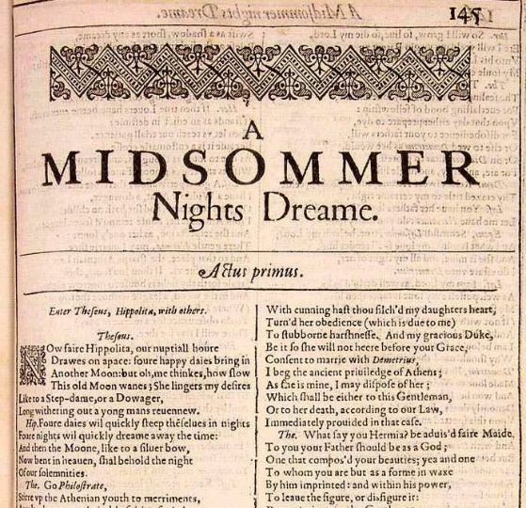
Then, there is a literary cul-de-sac peaking out for the reader’s attention, usually situated between the poetry, anthologies, and short stories. These are the plays. Yes, plays—not a shelf of “No Fear Shakespeare” that usually dominates most big box stores’ theater sections. A play might not shout out as the most appealing or obvious choice for your next beach read or nightstand companion, but inside those relatively minuscule slivers of paper are the monumental voices of some of civilization’s most important writers.

Now, I know what you might be thinking: “I’m not an actor or involved in theater. If I wanted to just experience these works of theater, I should just see them the way they’re meant to be seen: on stage.”

I will admit that reading a play, in theory, is a bit odd. It’s like absorbing a piece of art half-completed. You wouldn’t read a screenplay if you could just go watch the movie. And you wouldn’t just read lyrics if you could just listen to the complete song. A complete production, equipped with an ensemble of actors, direction, lights, sound, and scenic designs, performed on a stage is when every playwright’s vision can be fulfilled.

However, unlike every other art form, it’s theater’s ephemeral nature that makes reading plays not just an artistic blueprint. It’s an essential bridge to our creative past, present and future.

Music can be recorded. Novels exist on the page. Television and movies are sealed on crystalline digital discs. However, theater exists in the moment. Though it’s impermanence is what makes any night in a darkened theater thrilling (and oftentimes expensive), the only other way to enjoy the stories, scenes, and characters of the stage is in the written word of the playwright.

Whether it’s our oldest surviving plays from the likes of Sophocles, Aeschylus, Euripides, and Aristophanes, or today’s playwrights like Stephen Karam, Sarah Ruhl, Tracy Letts, Suzan-Lori Parks, Young Jean Lee, Stephen Adly Guirgis, Quiara Alegría Hudes, and Rajiv Joseph, playwrights capture the voices and conflicts of their particular age and life.

The literary voices of the playwrights in their dialogue and monologue-filled stories not only give you insight into the perspective and multiple personalities wrestling inside the author, but you get a front-row seat to the real and complex political, cultural, and personal dramas throughout most of history, proving that almost every play serves as an artistic reaction, in real time, to the issues of its day.

By its very nature, theater is a collaborative art. From the Dionysius Festival in ancient Greece, to high schools around the country, it does indeed take a village to put on a show. But when you inverse that equation, when it’s just one reader and one play, an ineffable alchemy takes place.

Novels, short stories, and poems all have the similar ability to whisk readers away with that all-too-familiar sensation of bearing witness to tales oftentimes adventurous, absurd, and appalling. Watching a live theatrical production is like buying a ticket to a live-action book. Audience members and readers alike are attentive and absorb what’s in front of them.
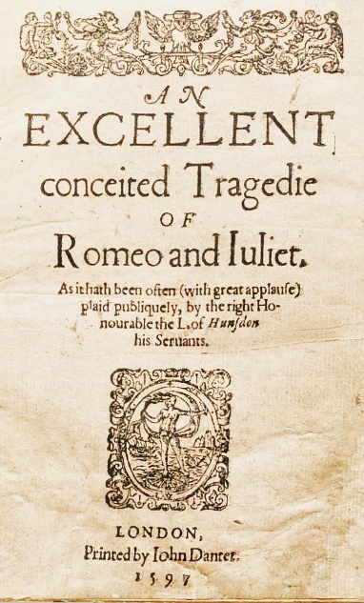
Play readers are much more. They are not passive fans; they are active participants. One really rediscovers the hidden meaning of the word play when picking up his/her first play—probably since high school English class. You can read silently in public or, for the more dramatic, out loud with friends. The dialogue, diction, and accents of the characters wash over you.
No matter who you thought you were or what you thought you knew before reading the play, by the time the curtain falls on that last page, you will have been transformed by read-speaking the words of characters familiar or new such as a tortured Danish prince, a Southern belle burning with sexual desire, or a bartender in a war-torn African nation serving up another round of survival. If nothing else, the simple act of reading a play makes everyone an actor, a shape-shifter.

Jumping back and forth between the voices and minds of the entire cast, the uninitiated will all but likely do a double take. You’ll flip back and forth of each scene to understand each nuanced detail of the plot, as well as the multifaceted nature of each character in your recently adopted fractured family.

When you dive into a play you are actor, director, and designer in one. It doesn’t take long before you begin to realize not only how hard each of those peoples’ art forms are, but you also feel for the struggles and euphoria that every character faces in their respective journeys in the play. How could you not? Each person’s words are tripping on your tongue. Before long, their problems, their joys, and their life meld with you own.

Any play is as potent a force for good as the most prestigious and dense novel. Plays and musicals are empathy supernovas. It’s that active understanding that give plays that unique ability to make a personal impact, large or small, with every read through.

In today’s age of social media of fast news and even faster judgments, absorbing a deliberate and streamlined dose of perspective is necessary. In addition, with a major political party’s presumptive nominee running a scorched earth campaign fueled by a fascistic sense of self-importance and paranoid ignorance, the legion of personalities and backgrounds encountered in any given play is medicine to the odious and divisive us-against-them discourse that has dominated this presidential campaign season.

As is evidenced by Lin-Manuel Miranda and Jeremy McCarter’s HAMILTON: THE REVOLUTION, the libretto and behind the scenes look at the creation of the smash hip-hop musical hit Hamilton, reading plays and musicals is an intoxicating experience most are realizing for the first time.

Reading a play is a literary metamorphosis that, once tasted, is hard to resist. So before you pick up your umpteenth celebrity biography or the most recent book by that Pulitzer Prize-winner, thumb through the drama section. An entire galaxy of stages awaits.

Nick Reichert is a recent transplant to Houston by way of Tennessee. An arts writer and history teacher by trade, he has written for American Theatre magazine as well as publications in New York, South Carolina and Florida. He has a bachelor’s degree in history from Wake Forest University and a master’s degree in arts journalism from Syracuse University. He can be found nose deep inside the magazine, plays, and history/biography sections.
- ______ (RI.9-10.1, RI 9-10.2)Which of the following best represent the main idea of the essay above?
  - In today’s age of social media of fast news and even faster judgments, absorbing a deliberate and streamlined dose of perspective is necessary.
  - When you dive into a play you are actor, director, and designer in one.
  - However, unlike every other art form, it’s theater’s ephemeral nature that makes reading plays not just an artistic blueprint. It’s an essential bridge to our creative past, present and future.
  - No matter who you thought you were or what you thought you knew before reading the play, by the time the curtain falls on that last page, you will have been transformed by read-speaking the words of characters familiar or new such as a tortured Danish prince…

- ______ (RI.9-10.4) Which word could best replace the bolded word potent?
  - Effective
  - Perturbed
  - Amused
  - Fairylike

- ______ (RI.9-10.6) Which of the following would be an idea that the author above would most likely agree with?
  - Theatrical trailers are a waste of time because they only give a sneak peek of what you will see in the movie.
  - Good stories allow readers to travel across time, space, universes, and into the shoes and lives of people and creatures of the unimagined and unlived.
  - Listening to music is only good if you know who the artist is and where their style originates from.
  - Obeying modern conventions of English will allow speakers to express their ideas clearly and concisely.

- ______ What does the author mean by the following figurative sentence:
Reading a play is a literary metamorphosis that, once tasted, is hard to resist.
- That you shouldn’t just read a play, but watch it too to get the full effect of the art.
- By reading a play, you are able to change into whatever you want, and that experience is addicting.
- That you should read plays in order to understand deeper meanings, and that it will become a good habit.
- By reading plays, you will grow as a human being and will need to expand to other genres like music, ballet, and paintings.

- ______ (RI. 9-10.5) How are the author’s idea refined by the following sentence:
It doesn’t take long before you begin to realize not only how hard each of those peoples’ art forms are, but you also feel for the struggles and euphoria that every character faces in their respective journeys in the play.
  - It provides a more in-depth look to the author’s opinion
  - It delivers an example of one way his opinion is correct, and therefore, valid
  - It demonstrates that the author’s opinion was initially wrong, but that he has grown from the experience.
  - It uses an anecdote to create pathos to persuade his readers towards his opinion

