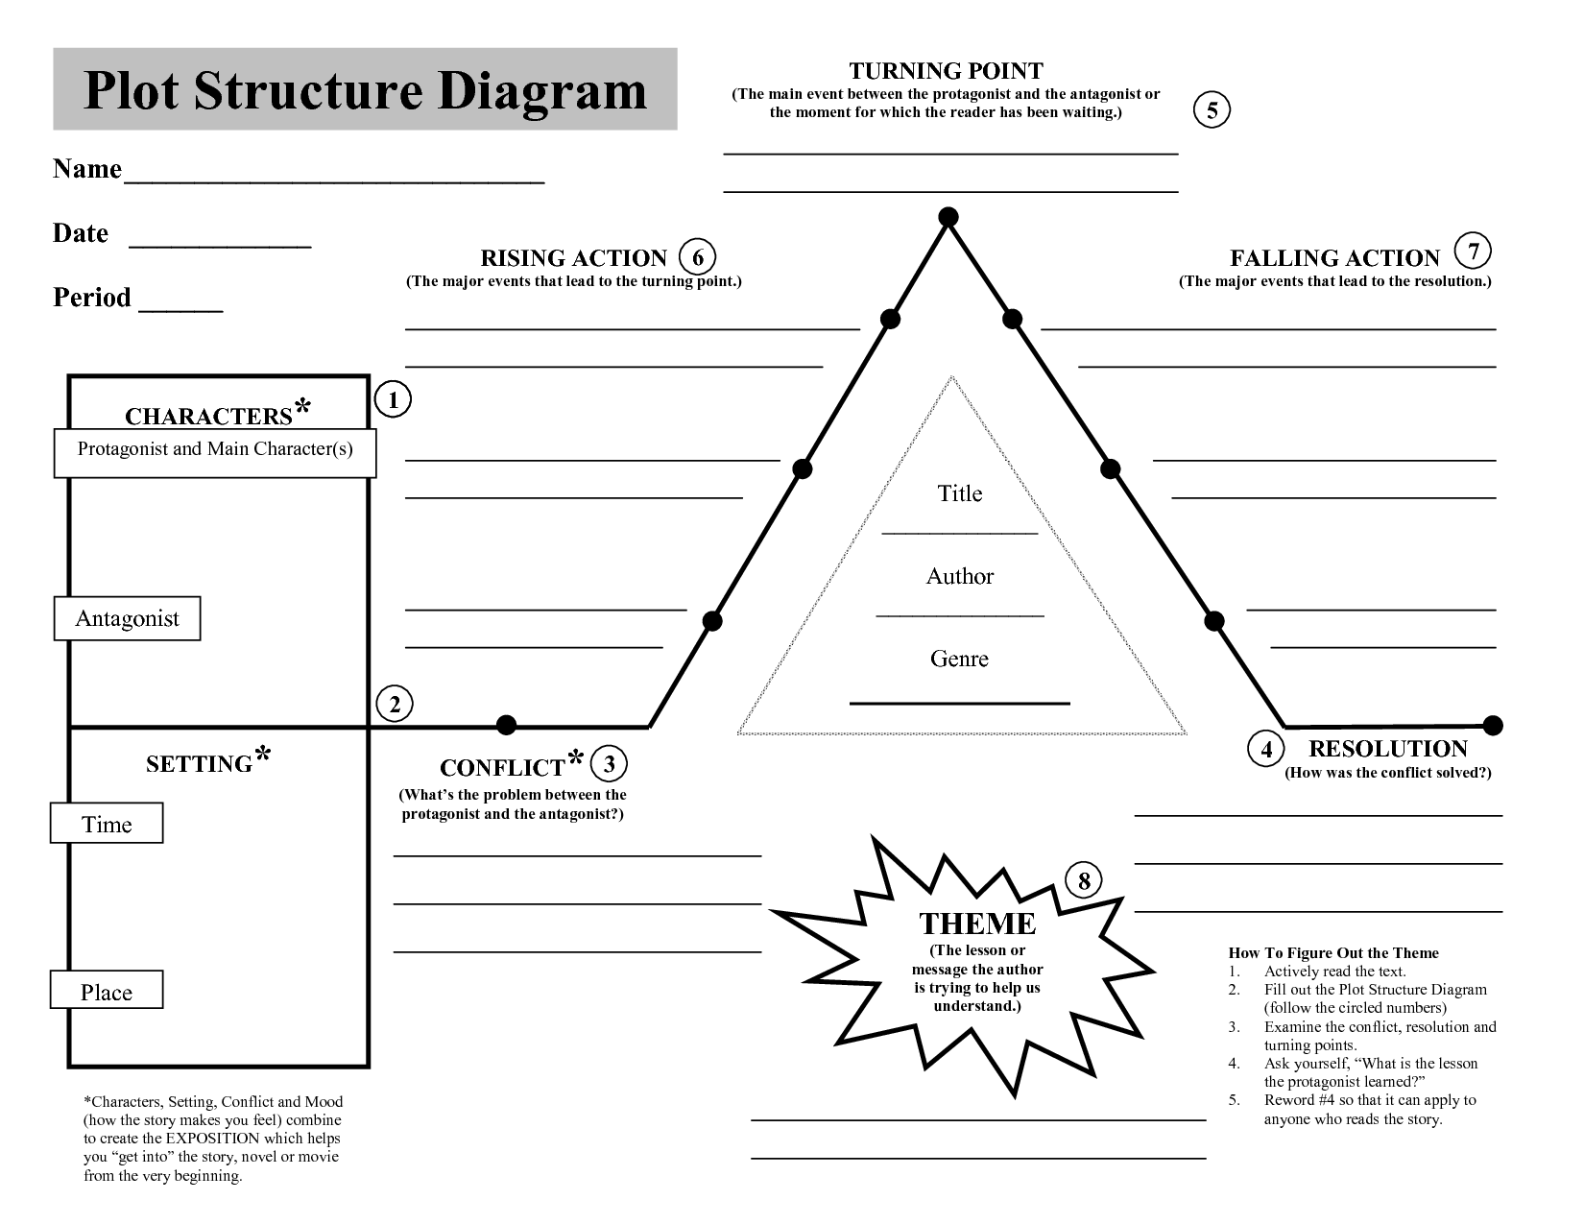

Point of View(circle)

First Second Third

Omniscient Limited

**10**

Title

Genre

**(Things that stand for more than what they are)**

**SYMBOLS**

**9**

Minor Characters

Protagonist

Antagonist

Major Characters

**2**

Place

Time

Mood

Setting

**EXPOSITION**

**(helps you get into the story from the very beginning)**