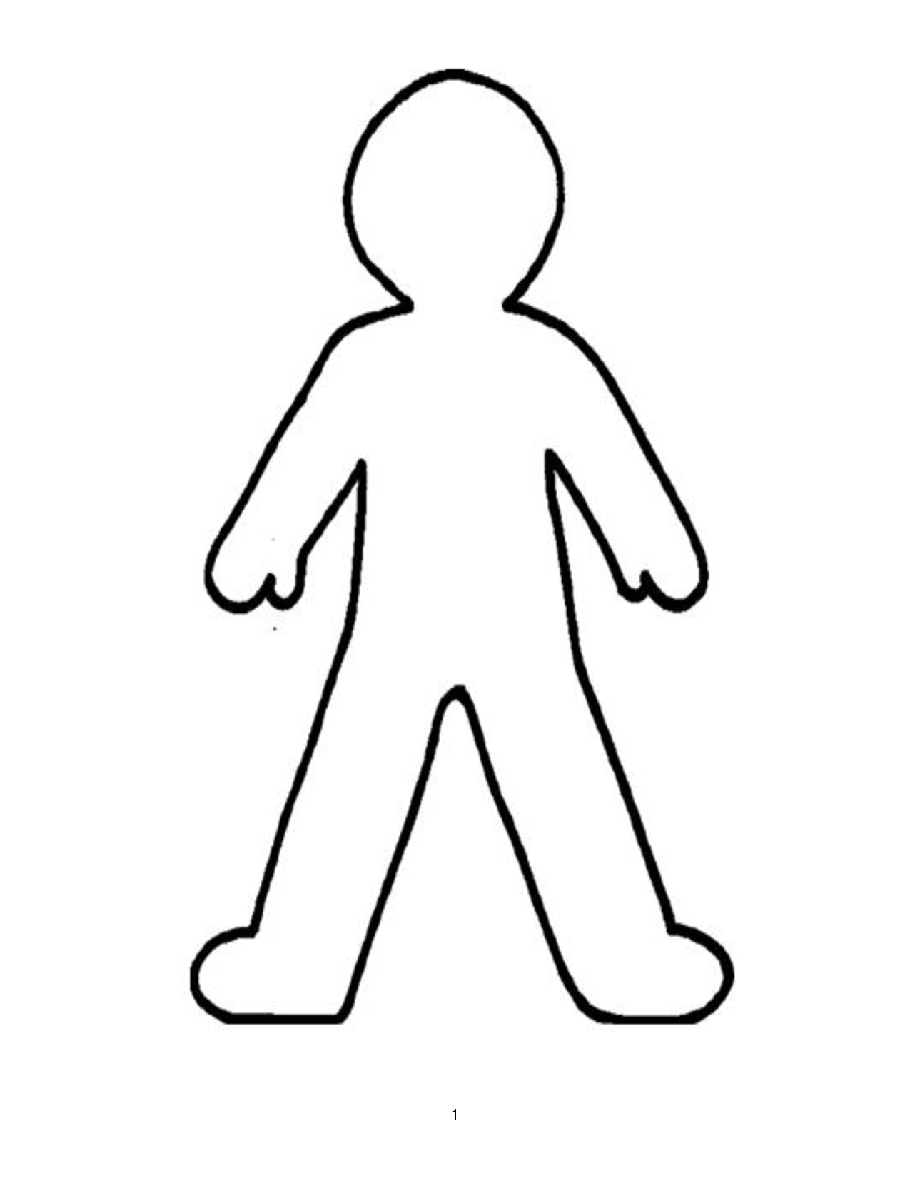
Character Portrait of Name:__________________________________
Explanation
Evidence:
Looks
Explanation
Evidence:
Speech
Evidence:
Explanation
Actions
Explanation
Evidence:
Emotions
Thoughts
Explanation
Evidence:

Direct Characterization:

Evidences:

