Grimsley High School
MLA Style Guide
By Michael J. Albert
Student: __________________
Class of: _________
Table of Contents:
Introduction …………………………………………3
Formulating an Argument ……………………….6
Support and Appeals ………………………..9
Writing Introductions …………………………….11
The Body Paragraph ……………………………...16
Writing Conclusions ……………………………….17
Summary, Paraphrase, and Synthesis ………..18
Selecting and Using Quotations…..…………….22
In-text Citations Technical Details ………..27
Formulating Works Cited Pages ………...........30
Works Cited Technical Details ……………..31
Works Cited ………………………………………… 39

Grimsley MLA Style Guide
Introduction: MLA? Like that bibliography stuff?
WHY???

That’s too much!
Ugh, so extra!

Why are you making us do this?!?!?!?! Great question. MLA can look really foreign and difficult, but the goal is quite the opposite: MLA is intended to help prove your point and avoid accusations of plagiarism in the simplest way. It may not seem that way at first, but stick with me a moment. Take this example:
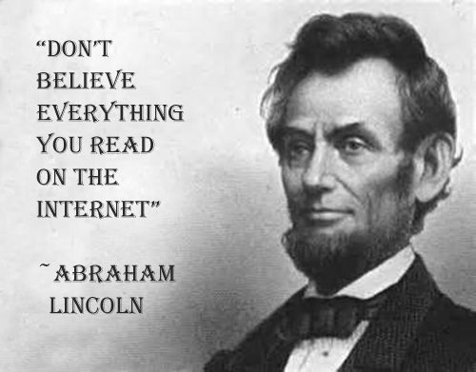(Troll Quotes)
That one’s pretty obviously not a Lincoln quote, but the point is clear: the age of information is also the age of misinformation and all those quotes you see on the internet may not actually be from who they say they’re from. Attribution is more important now than ever. If you attribute your source correctly, it puts some of the responsibility on your source. i.e. if you use an inaccurate quote or inaccurate information it looks like you’re lying and making stuff up to suit your own needs, but if you attribute that information to the source where you got it, at least that part of the burden is off your shoulders. (The part about poorly selecting sources isn’t off your shoulders, but we’ll talk about that later.)
Here are a few more Lincoln quotes that he probably never said:
- It will not do to investigate the subject of religion too closely, as it is apt to lead to Infidelity.
- If you look for the bad in mankind expecting to find it, you surely will.
- Marriage is neither heaven nor hell, it is simply purgatory.
- And in the end, it’s not the years in your life that count. It’s the life in your years.
- I am a firm believer in the people. If given the truth, they can be depended upon to meet any national crisis. The great point is to bring them the real facts, and beer.
(“Abraham Lincoln”)
I cannot tell a lie – I’ve even been fooled. We were reading The Alchemist by Paulo Coehlo one year and his philosophy sounded a lot like Ralph Waldo Emerson’s Transcendentalism. One quote in particular I thought must be an allusion, and sure enough the internet confirmed.
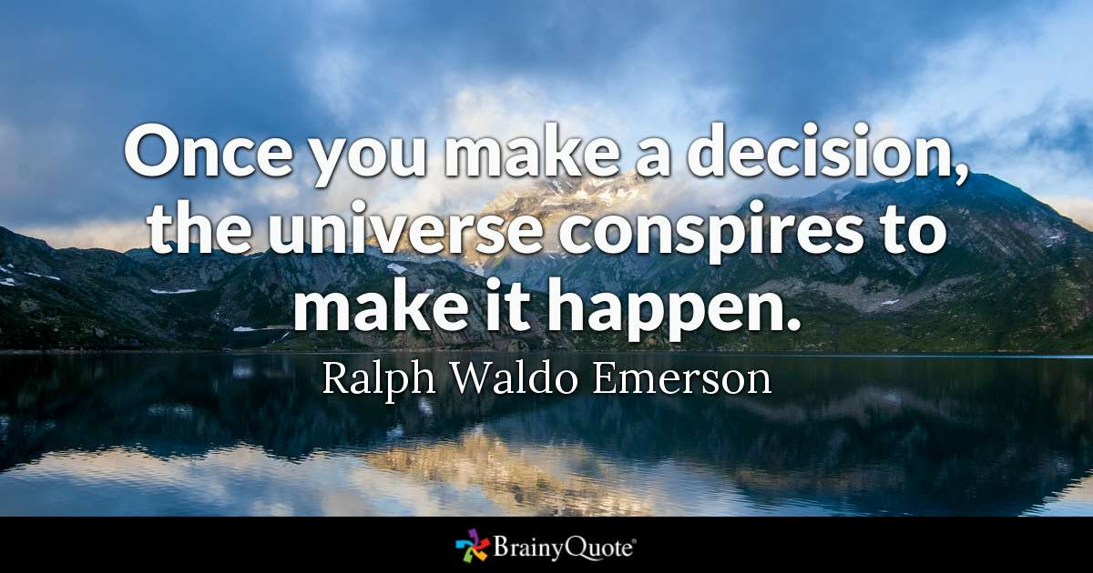 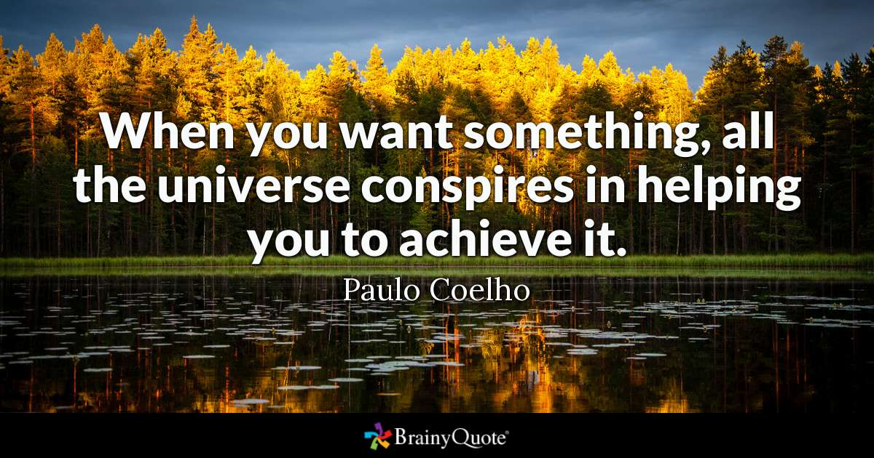Except, nope! I couldn’t find what speech or essay the Emerson quote came from – something that should be pretty easy in today’s age and a few CTL-F’s, but nope. Emerson never said the universe conspires to do anything.

Your audience should be able to check not only your logic, but also your facts and sources to make sure it all adds up
And this isn’t just about quotes on the internet! Some of these quotes were misattributed before the internet. Statistics and other things are made up, too #fakenews and that’s why you have to be really careful when choosing your sources.

The idea is not only that you are covering your own tail, but that you are creating a trail that others can follow to substantiate your results. Remember that scientific method stuff you learned in science class? An experiment isn’t any good if others can’t recreate your results. The same is true for a paper. Your audience should be able to check not only your logic, but also your facts and sources to make sure it all adds up (We’ll talk about avoiding cliché later, too ).

OK, so I get we should say where we got our stuff, but why this MLA nonsense?
Well, we need a universal way of citing sources and making sure readers can easily find our sources. There are several formats that various disciplines might use – APA (American Psychological Association) for psychology, Chicago Style for Anthropology, etc. but MLA (Modern Languages Association) is the easiest and most commonly used, thus it’s the one we use at Grimsley. Once you learn it, furthermore, if you ever have to use one of the others, the transition will be easy because the concepts are already there.

Introduction: “Simplicity, simplicity, simplicity!” (Thoreau)
MLA is supposed to be easy, but it can be really complicated to someone sitting in a high school classroom, so let’s talk about just how simple it is.
Basically, all you have to do is put the author’s last name or website title in parenthesis after your quote, statistic, or image. Then at the end of your document you have a works cited page that tells people how to find it. We’ll go over this in more depth later, but let’s take two of your most common sources as an example case, books and internets.
Did you know that once upon a time a giant named Thrym stole Thor’s hammer and Thor had to dress up as a bride in order to trick them and get it back? Pretty embarrassing for such a macho god! So “he hit Thrym with his hammer only once, but once was all it took. The ogre fell to the straw-covered floor, and he did not rise again” (Gaiman 123).
Notice all I had to do is put the author’s last name and page number in parentheses after the quote. I didn’t have to add the word or abbreviation for page, not even a comma! Then if you look at my works cited, under G for Gaiman, you’ll find the full reference so you can easily find the book for yourself if you like. Putting together the citation is pretty simple too, just fill in the blanks:
Last name: _Gaiman__, First name: __Neil__. Title: ___Norse Mythology__. Publisher: ___W. W. Norton & Company__. Publication date: __2018__.
All together, it looks like this:
Gaiman, Neil. Norse Mythology. W. W. Norton & Company. 2018.

Quoting from web sources isn’t much different. If you don’t have an author’s last name, use the username, if you don’t have that, use the web site’s name. Basically, just keep going down the list of what goes in the citation and the first thing you have you put in parentheses. If you are using a PDF that has page numbers like a book does, use the page number where you found it. If, like most websites, there is no page number, just the name is fine:
“Thrym says that he has hidden Mjölnir [Thor’s hammer] eight leagues beneath the earth, from which it will be retrieved, but only if Freyja is brought to him as his wife” (“Thor”).
Flip back to my works cited and you’ll find I filled in the blanks once again.
Author’s name or username: ___????___ Website title: __”Thor”__ Webpage name: __Wikipedia.org__. Publisher or Sponsoring Institution: __Wikimedia Foundation__. Date of last update: __23 July 2018__. URL or permalink: https://en.wikipedia.org/wiki/Thor. Date of access: __Accessed 28 July 2018__.
So all together it looks like this:
“Thor.” Wikipedia.org. Wikimedia Foundation. 23 July 2018.https://en.wikipedia.org/wiki/Thor. Accessed 28 July 2018.

The Basics of Formulating an Argument: Toulmin Method

When writing it is best to think of everything as an argument. Even if you are writing a history paper or a science report – it might feel like you are just restating facts, but you still want to include evidence and support and make a point, just like an argument. Let’s start with some vocabulary:
Claim: something you want to prove or impress upon your audience
Support: evidence, quotes, statistics, data, etc. that, well, supports your claim
Warrant: HOW does that support back up your claim?
Counterclaim: Addressing an argument your opponent or audience might make.
In short, you state your point (claim), then back it up with some support, and add some commentary on that support (warrant). Let me show you with a test case:
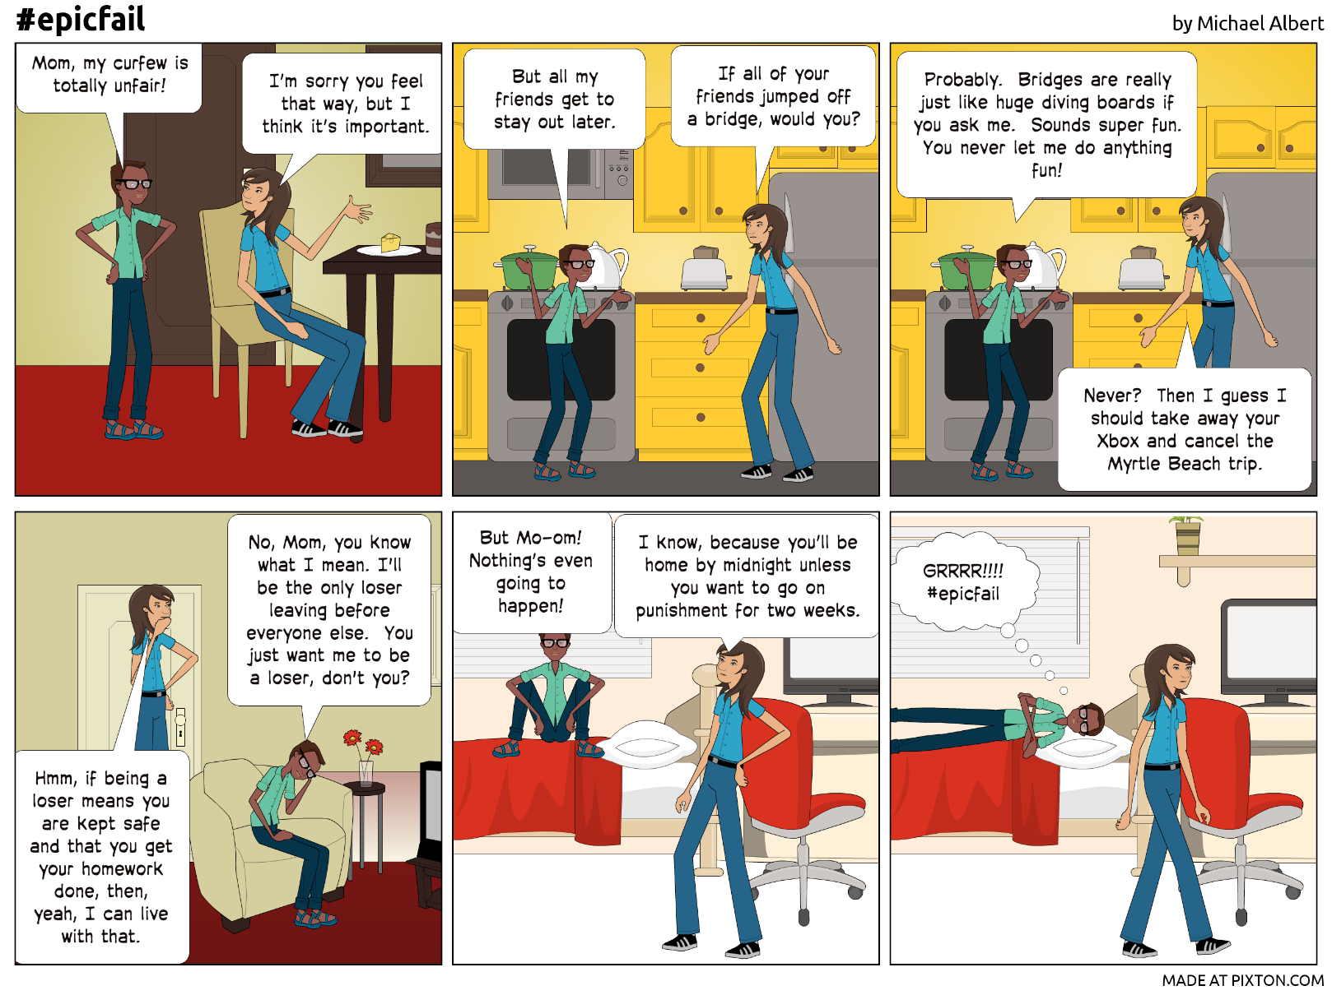
You had a claim, extended curfew, but got sidetracked by argumentative fallacies and lost focus.
Let’s try it again using the Toulmin method. First, list some of your supporting arguments and how that support connects back to your claim (warrant).
- Other kids my age get to stay out later. Psychologists and smart people say being able to socially develop at the same pace as my friends is really important #nochildleftbehind
- I’ve had the same curfew for two years. #notinmiddleschoolanymore
- I don’t usually get in trouble. Shouldn’t I get credit for good behavior or time served or something? Well, there was that one time that . . . oh, and the time that. . . . And then she’s gonna want to know if Marcus is going to be there because you know he’s going to be into something. You know what, maybe let’s not use this one.s
Add a counterclaim: Hmm, what is Mom going to say that I can refute before she even says it? Maybe I can come up with something that makes me sound smart, too . . .
- So, I know you’re going to say that high risk behavior and car accidents with teens increase with every hour later we’re out, but those are statistics, not individuals and those statistics drastically decrease with involved parenting. You’ve taught me well and helped me to understand the consequences of my actions. #flatterygetsyoueverywhere
- I’ll be careful; I’ll call if I need you; and this’ll help teach me how to be responsible. (Ha! If I’m going to beat a grown up, I need to sound like a grown up.)
Let’s try again:
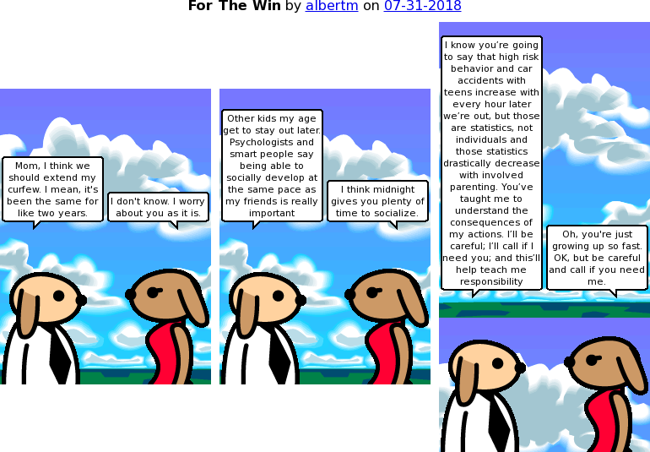
Created at wittycomics.com
The same concepts can be applied to other modes of writing such as expository writing (just a fancy word for explaining really) like in your non-English classes. If you are doing a history report, for example, you should still have a point – like maybe that George Washington didn’t really say “I cannot tell a lie” or that a contributing factor to the Civil War was the instability of the young American government after overextending itself in the Mexican-American War.
Or maybe in science class your lab write-up talks about how an experiment supported or refuted a hypothesis (claim). You do that with data (support) and explain HOW that data supports or refutes your hypothesis (warrant). You might even address other possible variables that may or may not have affected your results (counterclaim).
While writing certainly requires a lot of code switching, the basics are all the same: treat everything as an argument.
The Basics of Formulating an Argument: Support and Appeals
A good argument will have a variety of appeals and a variety of types of evidence. Let’s go over a few of the basics here.
Appeals: There are three basic types of appeals you can use to persuade your audience and give your ideas credibility. Sorry, if we get a little Greek and geek here.
Logos: as the name suggests, appeals to your audience’s sense of logic. Statistics and data work well as support here, but also just a sound progression of ideas. While it may often seem Logos is the best way to build an argument, you have to be careful in how you craft it. If there’s a hole or exception that you haven’t allowed for, it could sink your whole argument. Take Socrates famous syllogism as an example:
Major Premise: All men are mortal
Minor Premise: Socrates is a man
Conclusion: Socrates is mortal
Pretty simple, pretty logical . . . now what if we make a more modern example
Major Premise: All women like to shop
Minor Premise: John likes to shop
Conclusion: John is a woman. (“Syllogism”)
There are quite a few places we could pick that one apart, huh? I know what you’re thinking: “what the bleep is a syllogism and why are we talking about my brother’s obsession with finding good deals on basketball shoes on Ebay?” All right, we’ll save the rest for the chapter on logic. (Unless, of course, your teacher wants you to practice making syllogisms of your own and finding holes in each other’s arguments, hint, hint, hint. )

Ethos: appeals to a higher authority. I mean, you’re a high schooler which means that even though you know you know almost everything, everyone else thinks you know nothing, BUT everyone thinks Albert Einstein and Ben Franklin know everything, so if I can get them in on my argument . . .
If you’re writing an argument on the overemphasis on grades and achievement in school, for example, a quote like this – from someone who has excelled to the highest possible level in academia – could help add gravity (see what I did there, the astrophysics thing, get it? #baddadjoke) to your argument.
Curious that we spend more time congratulating people who have succeeded than encouraging people who have not. (@neiltyson)
Pathos: appeals to the audience’s emotions – it might draw them into feeling sympathy or empathy, or it could even use humor or sex appeal to attach positive emotions to a subject or idea. Pathos arguments are great ways to conclude after a series of logos and ethos, for example:
“Yes, revamping the grading system in our school is pretty radical and could even be costly, but isn’t the welfare and education of our children worth it?”
Striking a balance between appeals and evidence is important, but that balance may not always be the same. You might, for example, use more logic (logos) and data in a science paper, but in a paper about school safety, you might lean more towards the emotional (pathos) side of things, and in history and literature, ethos and quotes might get the stronger nod.

Types of Support: Advantages and disadvantages
Facts and statistics: These are great for building logical arguments and it’s tough to have a believable argument without facts, but there is a downside to packing too much data into your argument: it can get dry and unpersuasive. I mean, just about every apocalyptic movie has some scientist (sometimes referred to as an egg head) that no one listens to until it’s too late because he was too boring and technical to be persuasive. Therein lies the disadvantage of relying too heavily on facts and statistics #boooooring

Anecdotes and examples: can be really powerful and illustrative and add pathos to your argument, but they need to be paired with facts and statistics. Arguments based on case studies and individual testimony alone run the risk of being exposed as unsound. What if those examples are the exceptions, not the rule? While anecdotes and examples can give your argument life and color, too many can get repetitive and distracting.

Expert opinions: as we covered under ethos, quotes and opinions from reliable sources can help you take on some of their credibility. Too many quotes and paraphrases, however, can overshadow your own voice and even get list-like. Once again, balance is everything. Take a minute to research your sources, too. If someone exposes your quote as being out of context or establishes that your source was wrong in some other area, they can use that to undermine your argument. For example, did you know that Benjamin Franklin had a son who died at age four of smallpox because Franklin didn’t have him inoculated and Franklin’s other son was illegitimate and a British loyalist, so while Franklin could add ethos in lots of areas, parenting and fidelity is probably not one of them (Biography.com editors).

Putting Together an Essay: The Basic Format

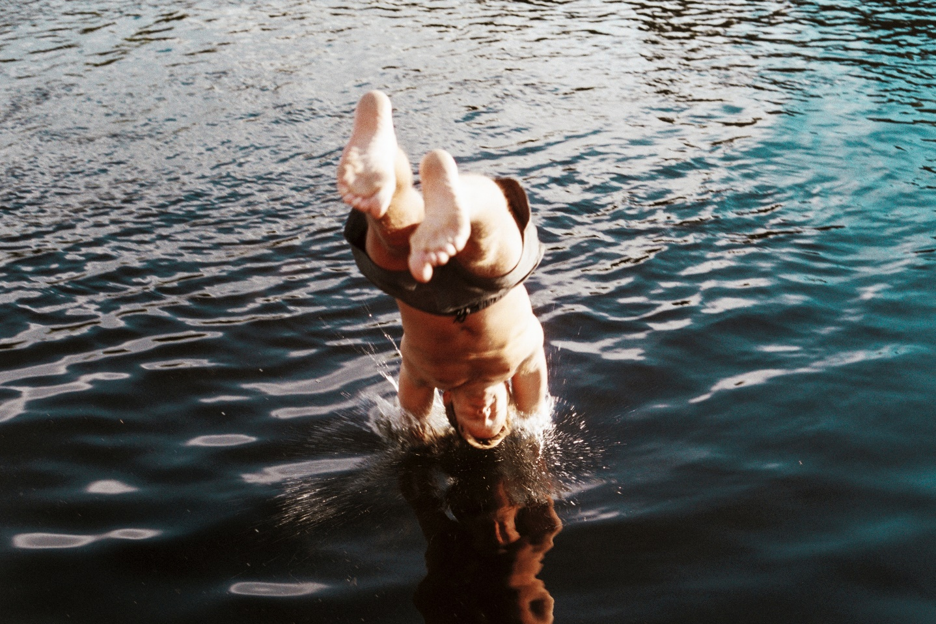
Introductions:
Wait, is that my phone in my pocket?
Photo by Jens Johnsson on Unsplash

Introductions should make a splash, but be sure your audience is ready.
Your introduction has a few basic purposes: to grasp your audience’s attention, establish the context for your argument, and to present your claim a.k.a. thesis. It INTRODUCES what you are going to talk about so your audience is prepared for what you’re going to tell them. You don’t want to take too long belaboring your point, but you don’t want to push your audience headfirst into your argument without giving them a chance to at least take the iphone out of their pocket, ya know what I mean?

Here are a few introduction strategies you might try in your own writing:

The funnel method: this is the easiest one to get you writing, but can be seen as boring or simplistic. When you just have to get the job done – go for the funnel. When you’re stuck and don’t know how to start, use the funnel. You can always go back and change your introduction later if you need to.

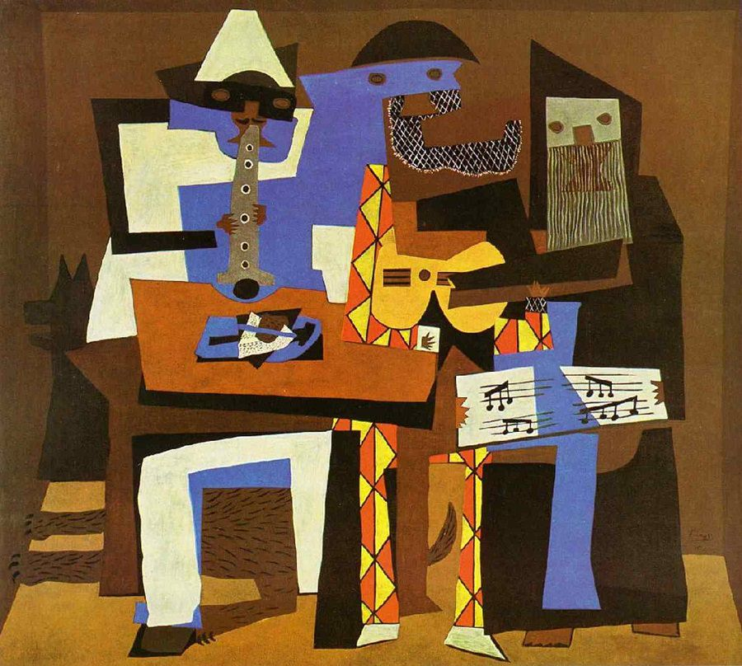
The Picasso: use imagery and draw your audience in with a dramatic picture.
Whoosh, chop! Whoosh, chop! A young man wipes the sweat from his brow. Hands are vibrating from all the blows, but the large V of fresh, yellow wood flesh is growing, much like his own strength, and he’s proud of himself. A few more swings and he’ll have it, his manliness proved! He hefts the heavy axe again, winds up all the might his body can muster and swings again, whack! Whack! WHACK! Timberrrr! The thirty foot giant is felled! Triumph! Until he notices a small pair of cherry buds on one of the branches. That’s why dad wanted him to wait – it’s the wrong tree! He knows he’ll have to face the consequences and the only response he can think of will become one of the most quotable lines in history: “I cannot tell a lie.” While George Washington probably never chopped down a cherry tree, this apocryphal tale can reveal a lot about the values America wishes to uphold and the character our first president would come to embody.
Ok, maybe that was a little melodramatic, but you get the idea. Also, introductions and conclusions tend to be areas where you can be more dramatic than the rest of the paper.
Three Musicians by Pablo Picasso

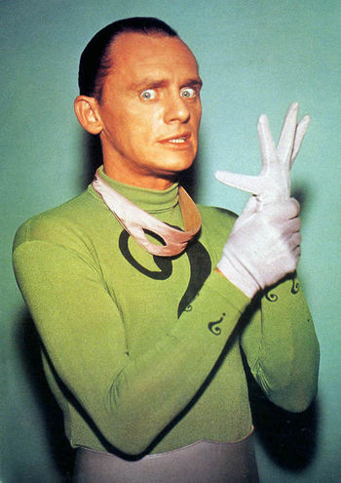
The Question: Use this one sparingly as it’s a middle school favorite and can give your writing a juvenile feel, but when used for the right subject or with the right audience, starting with a rhetorical question can really pull your audience in and help them to identify with your paper. Rhetorical questions can make your audience feel like they are coming to the same conclusion you are or can invite introspection, so make sure to craft your question in a way that meets your goals rather than just for the heck of it.
Remember the first time you realized Santa wasn’t real? The disappointment and disbelief – that your parents would lie to you like that, that those presents didn’t just appear out of thin air from selfless good will and altruistic elves? Life can be full of disappointments like that, but it doesn’t mean that we stop these things from being part of our culture because the values they represent and their roles in our culture are still there. The same can be true with our founding fathers. They were far from perfect, owning slaves, having affairs, fighting each other duels, but the stories we craft around them can tell us a lot about our culture. While George Washington probably never chopped down a cherry tree, this story can reveal a lot about the values America wishes to uphold and the character our first president has come to embody.
("Edward Nigma" from DC WIkia)
The ol’ Switcheroo – Lead your audience in one direction, then PSYCHE! Hit ‘em with your real claim. Like a good magic trick or backfield reverse, a little misdirection can lower your audience’s defenses and help you pick up some serious yardage.
Our nation is facing a pretty serious problem. Nearly every single American kid plays video games, some more than 40 hours a week. That’s time that they’re not exercising, learning, or interacting with others. We have a nation of disgruntled, socially maladapted, overweight tech addicts; potential hackers “sitting on their bed that weighs 400 pounds” (Trump qtd in Bump). We need to do something about video games for the sake of our kids’ social, psychological, and physical health, right? Wrong! What needs to change is the public view of gamers. New research shows that video games can actually help adolescents develop in each of these areas. They are actively doing something instead of just sitting there watching TV. They are problem solving and adapting. They are playing with family and friends. Gamers even tend to be less obese than our non-gaming counterparts.
Notice this example also ends with what’s known as a closed thesis. Each of those last sentences will then become the topic sentences of your body paragraphs. This can be a great strategy to keep yourself organized and focused.
The Smarty Pants: use a famous quotation to pull in your audience and establish ethos.
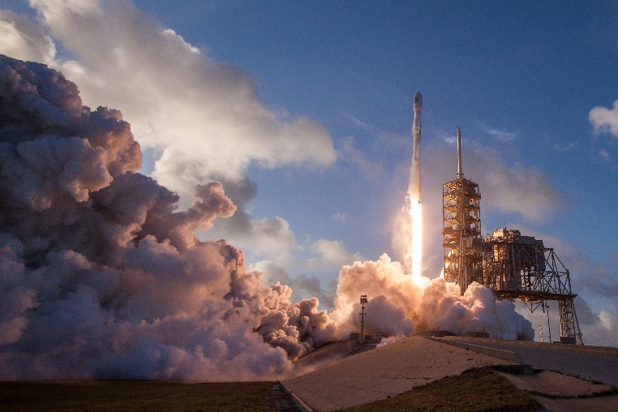
“Good habits formed at youth make all the difference” (Aristotle). How about a habit where kids learn how to focus on a series of tasks for long periods of time in order to reach a goal? Where they often have to work with others to finish these tasks, trying and developing new strategies, mapping out various scenarios in their imaginations, increasing computer literacy, and even honing their own physical coordination? Sounds like a pretty good habit to form, right? Contrary to many popular beliefs, this is exactly what video games do. Don’t believe me? How about one of the world’s foremost engineers and the guy who’s probably going to get us to Mars and back, Elon Musk: “I like video games [laughs]. In fact, that’s what got me into software engineering when I was a kid. I wanted to make money so I could buy a better computer so I could play better video games” (qtd in Clash).
Notice these last two examples had elements of the switcheroo, the Picasso, the funnel, and the question. It’s very common and a good idea to combine elements of various strategies, mix in your own style, maybe even a dash of cinnamon or cayenne to give your writing flavor and kick.
Photo by SpaceX on Unsplash
Analyzing Literature:
Introductions for literary analysis follow a similar format. Your goal is to get the reader’s attention by provocatively introducing your argument while establishing context. Typically 3-5 sentences is sufficient for this paragraph, though more complex arguments and lengthy essays may support a slightly longer introduction. Just like the previous examples, a literary analysis will often focus on the effects of a certain device or strategy employed by the author. Use one of the openers from above, such as imagery or funnel, or preview your strongest point, then transition into your thesis, which should include the following three parts:
3 Part Thesis: Context + verb + device or strategy + strong verb + analysis
Context = author and title – no pronouns. If you have already established this earlier in the introduction, use the author’s last name.
Device or Strategy: You may wish to talk about technical literary devices such as metonymy, apostrophe, metafiction, etc. but you don’t have to. Seemingly simple things like selection of detail and perspective are also strategies. The important part is not to go device finding – here’s a symbol, here’s imagery, etc. – but to talk about their effects and the ideas presented in the work as a whole, i.e. the analysis.
Analysis: Here’s the important part. Here’s where you break down the story behind the story. Some call it theme or message. Identifying the literary elements and strategies is the HOW, analysis is the WHY.
Examples:
In the novel Pride and Prejudice, Jane Austen uses the caricatures of Mr. Collins and Mrs. Bennett to highlight the fickleness of class worship and marrying for money in nineteenth century England.
The novel Middlesex by Jeffrey Eugenides traces the history of an intersex protagonist to explore the artificiality and narrowness with which we approach gender constructs in our society.
In the memoir A Long Way Gone, Ishmeal Beah’s selection of dream sequences act as a representation of the internal conflicts he, and likely many soldiers, experience well into adulthood.

The Body Paragraph:
Body paragraphs are the real meat of your essay so be sure to put something in there for your audience to chew on. No more of that vacuous 3-5 sentence stuff from elementary school. In a high school academic paper, you should have at least 6-8 solid sentences. Start with a topic sentence, then support it with a fact, statistic, anecdote, or quote, add some logical commentary on your support (warrant and grounds), then transition to your next piece of supporting evidence and repeat as necessary until your topic is proven enough to move on to your next topic and next body paragraph.

Video games provide kids with a platform to learn how to problem solve and adapt in order to reach a goal. In fact, there are dozens and dozens of positive impacts of video games on cognitive development, for example: “The player cannot get through with what they already have or know and must find new combinations and incorporate old skills with new skills to overcome obstacles [ . . . ] (Gee, 2003). In relation to this, the player can also learn strategy and anticipation, management of resources (simulation games), mapping, pattern recognition, how to judge the situation and practice reading (with directions, dialogue, etc.) and quantitative calculations [ . . . ] (Tumbokon, 2014)” (Dai and Fry). Simple games like Angry Birds or Cut the Rope teach younger kids how to solve puzzles with immediate feedback (Tumbokon). In a role playing game like Sims or World of Warcraft, older kids have to learn how to balance responsibility and resources on a larger, more sophisticated scale. Even those demonized first person shooter games like Call of Duty increase kids mapping abilities and fine motor skills needed in things like surgery. “Simone Kuhn, a researcher at the Max Planck Institute for Human Development in Berlin, has found that the prefrontal cortex actually grows thicker and gray matter more voluminousin people who play games as humble as ‘Super Mario 64,’ changes that could improve memory and navigational ability” (Keilman). With GPS programs on every phone, almost no one really uses a map anymore and video games are filling in that gap in cognitive development. As video games evolve, furthermore, so does the complicated problems that need to be solved and the level of skill required by the gamer. Often times, it simply cannot be done alone.

Conclusions:
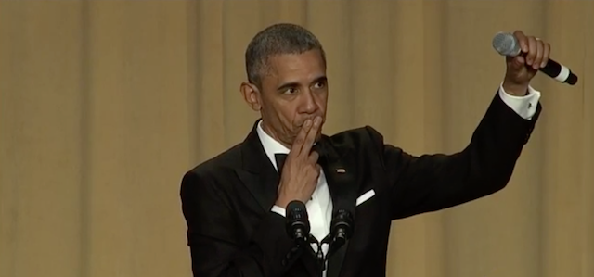
A lot of students worry too much about their conclusions and what to write. All you really have to do is synthesize and drive home the points you made in your paper. The conclusion is basically a reflection of your introduction – moving from specific back out to general statements – and a chance for you to assert your opinion or a call to action.
Vibe.com President Obama Mic Drop

You ever type a way-too-long text message, but, hey, you typed it so you might as well send it? Or go to leave a voice mail and then leave a ridiculously long message because you were rambling and if you stopped now that would be abrupt and awkward, so, um, yeah, call me, I guess, if you get a chance, you know, when you get this, or whatever? Yeah, don’t do that. With conclusions, less is more. Make your point, drop the mic, and get out.

Another way to think about it is: a conclusion should answer the question, “so what.”
Summary, Paraphrase, and Synthesis:
Writing good summaries, paraphrases and syntheses is a great way to learn specific topics and to prepare you for larger and more complex writing tasks.
A lot of people use these terms interchangeably, but each one is a little different and has a slightly different purpose. Summary is the simplest and something you’ve probably done many times.
Summary is shortening and simplifying a work.
To write a summary, read the entire source, identify the main ideas, and choose a few details or quotes to help illustrate and capture the feeling of the original. Consider the following article from Sports Illustrated, for example:

Fantasy Football 2018: Quarterback Tiers

By MICHAEL BELLER August 17, 2018
Rankings are the backbone of fantasy football draft prep season, but there are more to rankings than meets the eye. Every position has multiple drop-off points, where the fantasy value takes a dip. Knowing where these breaks are can help you make the right call on what appears to be a tough decision. That’s why after you rank the players at every position, you must then put them into tiers.
The idea is simple. While you might prefer Russell Wilson to Tom Brady, you understand that the bottom-line difference between the two is minimal, thus placing them in the same tier. When multiple players in the same tier are still available, you may be able to wait on filling that spot on your roster. If you’re at the end of a tier, though, you’ll need to address it if you don’t want to have to drop down to the next group.
In this column, we look at quarterback tiers. Click the links for running backs and wide receivers to dive into those positions.
Tier One
(1) Aaron Rodgers
The best quarterback in the league, from both real-life and fantasy perspectives, without question. Tom Brady is more accomplished, but Rodgers is the better pure quarterback. That’s what puts him in a tier by himself.
Tier Two
(2) Deshaun Watson
(3) Russell Wilson
(4) Tom Brady
(5) Drew Brees
You know exactly what you’re getting with Wilson, Brady and Brees. Those guys all have established levels of high performance, and it’d be a surprise to see any of them come up short of what their track records say they should do. Watson is a wild card, but we all saw what he did before tearing his ACL last year. I realize the sample was small, but he was clearly the best player on the field in every game he played, including the one that featured Wilson. That doesn’t happen by accident.
Tier Three
(6) Cam Newton
Newton has a higher ceiling than everyone beneath him, and a lower floor than everyone ahead of him. He has been a top-three quarterback in three of the last five seasons. In the years he wasn’t, he finished 17th and 15th. He’s not quite as safe as he seems, but when he puts it all together, he’s a scoring machine.

Take a few notes as you read:
Integrate these into your first sentence or two.
Title: “Fantasy Football 2018: Quarterback Tiers”
Author: Michael Beller
Main Idea: How to use logic and strategy in your fantasy football draft
Supporting Ideas: Instead of letting fandom determine your fantasy football picks, break positions into tiers
If there are a lot of players in a specific tier, choose one later in the draft.
A safe, consistent pick is better than one with a lot of potential but inconsistency
Important Quotes or Details: Cam Newton is a tempting, but unsafe pick “He has been a top-three quarterback in three of the last five seasons. In the years he wasn’t, he finished 17th and 15th.”
Even though Watson is a wild card, his inconsistency came from an injury and “he was clearly the best player on the field in every game he played, [ . . .] That doesn’t happen by accident”
These would need in-text citations if you didn’t already establish the author or if the article had page numbers

Super Important Caveat: You really want to digest and understand the information before you start spitting it back out. That’s why you want to write a summary from your notes, not directly from the article. Not only do you understand the content better when you do it this way, but going right from the article often results in suspicious wording and inadvertent plagiarism.
All together, it might look like this:

In the article “Fantasy Football 2018: Quarterback Tiers” from Sports Illustrated Michael Beller advises the reader on some ways to use logic and strategy when picking fantasy football rosters. Players are broken into tiers based on their expected performance. If you are looking at a player in a tier that still has many players in it, you should wait until later in the draft. A player like Deshaun Watson might be a bit of a wild card due to his limited play, but a truly risky player like Cam Newton is one who might score a lot, or who might just play mediocre “[Newton] has been a top-three quarterback in three of the last five seasons. In the years he wasn’t he finished 17th and 15th.” I have a hard time overcoming my bias with Newton, though, and if he’s available, I’m going for it. After all, “when he puts it all together, he’s a scoring machine” (Beller).
Paraphrase is like summary but is typically a similar length to the original work might use similar wording. When students say they “put it into my own words” that’s paraphrasing and requires a citation.
Well, then why not just summarize or quote, you might ask. Paraphrasing might allow you to integrate others’ ideas into your own when the original quote won’t quite fit or work with your voice at that moment. You might paraphrase something complicated that needs simpler language, but that can’t really be shortened down the way a summary is.

Here’s a paraphrase of the second paragraph of that article:
Using tiers in a fantasy draft is simple. Even though you might like one player over another, the difference in what the 4th ranked quarterback will bring your team versus the 3rd ranked quarterback might be insignificant, so if you have a bunch of players with a similar rating – on the same tier -- still in the draft, you should wait to draft that position. When you’re getting towards the end of a specific tier, that’s when you should snap up one of those players (Beller).
Notice you still have to cite paraphrases even if you don’t use any direct quotes.

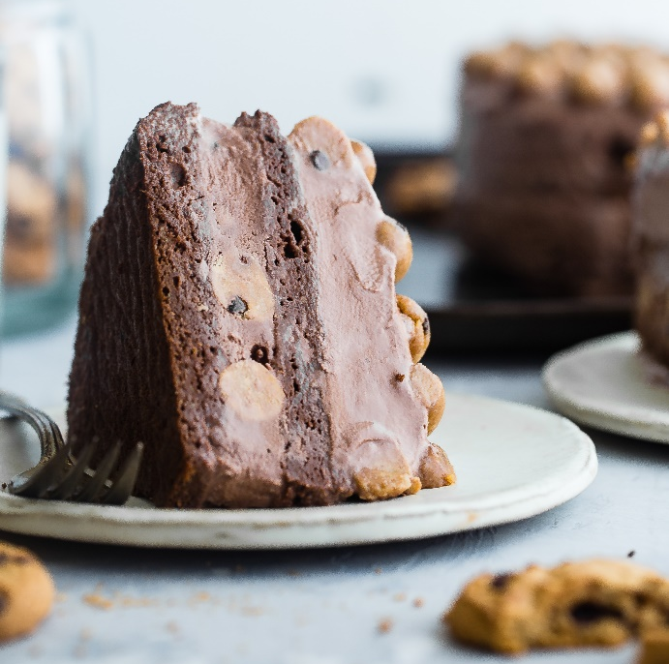
Synthesis is like a paraphrase, but in a synthesis you are bringing various sources together. Rather than writing separate summaries or paraphrases and putting them into a list-like fashion, a good synthesis will mix and intertwine the sources throughout. You ever have a cake that someone didn’t mix up well enough and it didn’t rise right and you’re crunching on undissolved sugar and eggshells and stuff? Yeah, you don’t want that. You want a nice smooth, balanced cake with flavors that complement each other.

Let’s take some elements of our Michael Beller summary from above and mix in some information from Sporting News’s “2018 Fantasy Football: Best Ball Draft Strategy Guide, Tips, Targets” by Howard Bender.
In the article “Fantasy Football 2018: Quarterback Tiers” from Sports Illustrated Michael Beller advises the reader to break players into tiers based on their expected fantasy performance. If you are looking at a player in a tier that still has a lot of players in it, you should wait until later in the draft. Likewise, Howard Bender advises patience and even to leave quarterbacks for later draft rounds, noting the small difference in performance among quarterbacks of a similar tier: Between the third highest scoring quarterback, Tom Brady, and the seventh, Philip Rivers, there was only a 22 point difference (Bender). A player like Deshaun Watson might be a bit of a wild card due to his limited playtime last year and lands in Beller’s second tier just under Aaron Rogers, but both authors tote his potential “I’ve been pounding the Deshaun Watson drum a lot this offseason” (Bender) but he notes you can still wait until the fourth round “because running backs are your bread and butter.” While a promising quarterback might be a tempting but unnecessary early round pick, Beller also advises caution around a truly risky player like Cam Newton, who was second last year “has been a top-three quarterback in three of the last five seasons. In the years he wasn’t he finished 17th and 15th” (Beller). So use the tier systems to grab running backs – keeping in mind unpredictable players -- in the first rounds, quarterbacks starting in fourth or fifth rounds, and wide receivers later.
When you combine the information in both articles, this is the crux of what you glean from it. Statements like this are good to keep you from getting overwhelmed and losing your voice in the midst of all this information.

Remember, summary, paraphrase and synthesis might be assignments or assessments of their own, but they are also parts longer of arguments and sustained writing. Getting lots of practice with them will really prepare you for a variety of tasks in college or the job place.

Quote Integration and In-Text Citations:

WHY? As we’ve seen in our examples so far, using quotes, statistics, and various forms of evidence is an important part of writing. Not only does this lend ethos, clout, and support to your argument, but also most things we write about people have already written about and studied. We’re joining the conversation with our own perspective. It’s important to show we know a little something of what we’re talking about and that we’re building on that conversation.

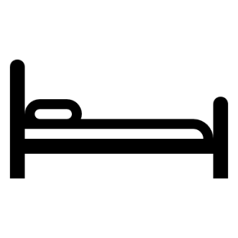
HOW MUCH? When adding evidence to your writing it’s important to find the right balance. Too little and your argument can seem vague and unfounded. Too much and you lose your argument and your audience wonders why they’re reading your writing and not the writing you are quoting from. Remember, it’s still YOUR paper and you want to make sure to maintain YOUR voice and not be overpowered with your sources. Quotations and evidence should support your argument, not make it for you.
Think of it like “Goldilocks and the Three Bears”:
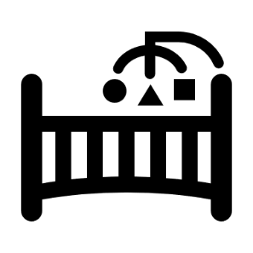
A paper overpowered with quotes and data is too hard and might not be that interesting or persuasive despite all that evidence.

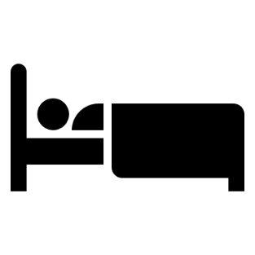
A paper with not enough quotes and data will be too soft and vague to be persuasive or effective.

But a paper with just the right mix of quotes and evidence, of ethos, pathos, and logos, will be juuuust right. There’s no set rule on how many quotes you can have in a paragraph – and it will vary depending on your subject and the type of writing you are doing – but in most high school papers, about two quotes per paragraph should do it.

WHAT to use and what not to use:
Obviously you want the best support for your argument and should keep this in mind when choosing quotes and statistics, but what will best support your argument isn’t always clear to young writers. Think about what has the best logic and the most pop. As you are reading, annotate and keep note of stuff that sounds really smart, then when you go to do your own writing, choose from that list so you aren’t overwhelmed by all of your resources. Choose quotes and data that is succinct over stuff that’s wordy. Choose quotes and data that are interesting and insightful over stuff that most people know or accept already. Choose quotes and data that represent ideas that aren’t yours and that really need attribution. Let’s play a round of good quote, bad quote.

Quote Selection and Integration:
Just like an unwanted glitter bomb or water balloon from a friend who’s not quite as funny as he thinks he is, you don’t want to just plop in quotes unexpectedly then run away. Always set up your quotes with a topic sentence or claim and lead your audience into what you want them to glean from the quote. Then analyze – don’t just restate – the quote and tie it back to your topic sentence or claim. #warrant
“But all these quotes will make my paper so pretty!”
Photo by h heyerlein on Unsplash
“Too much, Darnell, TOO. MUCH!!!”
Check it out:
Most people have heard about the Great Pacific Garbage Patch, that huge collection of plastic debris the size of Texas in the Pacific Ocean, but it seems a lot of people write it off as being from the days before recycling was popular. The fact is, however, that plastic production and waste continues to grow exponentially “Virtually half of the plastic ever manufactured has been made in the past 15 years” (Parker 59). Just think about how long a plastic shopping bag is used for or how much plastic packaging was lying around your living room last Christmas morning. It’s everywhere! Yes, most American communities have recycling programs, but not everyone follows them and America only accounts for 4.29% of the world’s population (Migiro). This problem is growing fast.
Let’s try that again. The previous example was a pretty simple summary of the issue and what to use and how to use it can get more complicated as you get into more detail. Take a look at another section of the National Geographic article that was quoted in the previous paragraph.
Notice I saved my quote and statistic for facts that really need backing up so it doesn’t look like I’m just pulling things out of my derriere, but I didn’t put excessive quotes about the Garbage Patch or recycling programs because that would be just TOO. MUCH!
How do I choose what to quote and integrate it into my own writing? Start by thinking about what point you want your paragraph to make. That we should use less plastics in packaging? That other countries should step up their recycling game #avoidcliche? That we should classify plastic as a hazardous material? That we should boycott Coke?
Then once you have your focus, think about which part or parts best illustrate and serve your purpose. Let’s focus on the idea that other countries need better waste management and highlight what best goes with that.
Six decades later, roughly 40 percent of the now more than 448 million tons of plastic produced every year is disposable, much of it used as packaging intended to be discarded within minutes after purchase. Production has grown at such a breakneck pace that virtually half the plastic ever manufactured has been made in the past 15 years. Last year the Coca-Cola Company, perhaps the world’s largest producer of plastic bottles, acknowledged for the first time just how many it makes: 128 billion a year. Nestlé, PepsiCo, and others also churn out torrents of bottles.
The growth of plastic production has far outstripped the ability of waste management to keep up: That’s why the oceans are under assault. “It’s not surprising that we broke the system,” Jambeck says. “That kind of increase would break any system not prepared for it.” In 2013 a group of scientists issued a new assessment of throwaway living. Writing in Nature magazine, they declared that disposable plastic should be classified, not as a housewife’s friend, but as a hazardous material.
In recent years the surge in production has been driven largely by the expanded use of disposable plastic packaging in the growing economies of Asia—where garbage collection systems may be underdeveloped or nonexistent. In 2010, according to an estimate by Jambeck, half the world’s mismanaged plastic waste was generated by just five Asian countries: China, Indonesia, the Philippines, Vietnam, and Sri Lanka.
“Let’s say you recycle 100 percent in all of North America and Europe,” says Ramani Narayan, a chemical engineering professor at Michigan State University who also works in his native India. “You still would not make a dent on the plastics released into the oceans. If you want to do something about this, you have to go there, to these countries, and deal with the mismanaged waste.” (Parker 59)
OK, that’s still pretty big though. If you really, really, need all of it you can use a block quote like we just did (start quotes over four lines on a fresh line with an additional ½” margin and no quotation marks). You can summarize or paraphrase parts. Or, you can use an ellipsis (three periods separated by a space) to eliminate parts that are too long, confusing, or less relevant to your argument.
So you might say: Asia has driven most of the mismanaged plastic waste in recent years as their consumption has far outstripped their underdeveloped or nonexistent garbage collection. “’Let’s say you recycle 100 percent in all of North America and Europe,’ says Ramani Narayan, a chemical engineering professor at Michigan State University who also works in his native India. ‘You still would not make a dent on the plastics released into the oceans’” (Parker 59).

Or to use an ellipsis: “In recent years the surge in production has been driven largely by the expanded use of disposable plastic packaging in the growing economies of Asia—where garbage collection systems may be underdeveloped or nonexistent. [ . . . ] ‘Let’s say you recycle 100 percent in all of North America and Europe,’ says Ramani Narayan, a chemical engineering professor at Michigan State University [ . . . ] “You still would not make a dent on the plastics released into the oceans‘” (Parker 59).

Quote Integration, It’s Like Good Highlights
You’ve selected and trimmed your quotes, now let’s talk about how to work them into your writing smoothly without losing your natural voice. Good quote integration is like good highlights: it flows and works with your natural hair, highlighting its good qualities. Bad highlights? Well, not only do they look bad and chunky, but they make your hair frizzy and out of control and work against its natural strengths. You really want to make sure you work in those quotes carefully – so get out your combs and gloves and let’s do it right! Good quote integration will make your paper lively and healthy and beautiful! Awkward quote integration can make your writing dull, drab, boring, and, well, awkwaaaaard!
Photo by Jessica Castro on Unsplash
Time for another round of good quote, bad quote:

In-Text Citations Technical Stuff:

Super Important Caveat!!!: While this covers the vast majority of situations you will encounter, the types of sources we use is constantly changing and expanding. If you encounter a situation or source not addressed here, or if you simply are unsure, check out an online guide as they are updated frequently. MLA has its own website (https://style.mla.org/) but Purdue University’s Online Writing Lab is probably the best resource out there for this stuff (https://owl.purdue.edu/owl/research_and_citation/mla_style/mla_formatting_and_style_guide/mla_formatting_and_style_guide.html).

MLA in text citations (also known as parenthetical citations) are quite simple. In most situations all you have to do is put the author and page number in parentheses after the quote or paraphrase, like so:
Callie’s brother experiences the disparity we have in coming to terms with the randomness in nature when he tries to escape “the possibility that not only his draft number was decided by lottery, but that everything was” (Eugenides 317-18).
Author’s last name Page # Period outside parenthesis instead of in quote.

If you have a quotation mark within your quotation (if you are quoting a story that has dialogue in it, for example) use single quotation marks.
“’You are too sensible a girl, Lizzy, to fall in love merely because you are warned against it; [ . . .] you must not let your fancy run away with you’” (Austen 144).
Use brackets when you add an ellipsis
Add single quotation marks when quoting a quote

Line breaks in poetry should be indicated by a slash, like so:

“The Whiskey on your breath / Could make a small boy dizzy;” (Roethke 997)

Block Quotes: If a quotation is more than four lines, omit the quotation marks, start on a new line, increase the left margin by 1/2” and cite at the end, like so:

In going underground, I whipped it all except the mind, the mind. And the mind that has conceived a plan of living must never lose sight of the chaos against which that pattern was conceived. That goes for societies as well as for individuals. Thus, having tried to give pattern to the chaos which lives within the pattern of your certainties, I must come out, I must emerge (Ellison 580-81).

Citing Plays: Often times citing a play is the same as citing anything else: author and page #
Buuuuuut, if you are quoting from a play listed with act, scene, and line, cite accordingly:
“And thus the Whirligig of time brings in his revenges” (Twelfth Night V.i.399).
Note, you can often leave off Shakespeare in your in-text citations, (because, you know, he’s Shakespeare. Everyone knows Shakespeare) unless it’s not obvious, like quoting one of his more obscure plays or if you haven’t established you’re talking about Shakespeare.

Citing Scripture: When citing from the Bible, include what version you are using in italics, then the book of the Bible (no italics) followed by chapter and verse. Like this
God first spoke to Moses through the famed burning bush: “There the angel of the Lord appeared to him in flames of fire from within a bush” (The NIV Study Bible Exodus 3:2).

If you’ve already mentioned the author or it’s clear from your writing, just put the page number.
Author’s name is in the text, so we don’t need it in the citation.

Eugenides explores the randomness that rules the universe and the disparity that results when we realize our universe is not as ordered as we thought, thus Callie’s brother uses acid to escape “the possibility that not only his draft number was decided by lottery, but that everything was” (317-18).

If your source has more than one author, just add an and.
“Gamers also get used to multitasking. As games become more intricate, players must juggle different objectives while keeping track of all the changing elements and connecting ideas” (Dai and Fry).

If you are quoting from a source without pages, like a website, all you need is the author’s last name (See previous example). If, however, your web source does have page numbers, like many of the PDFs out there, use the page numbers.

If your source doesn’t list an author, just put the title in parenthesis (long titles can be shortened). Basically, whatever comes first in your works cited entry should be in the parentheses. This way your in-text citation directs the reader to the works cited entry simply and easily.
“The Great Pacific garbage patch, also described as the Pacific trash vortex, is a gyre of marine debris particles in the central North Pacific Ocean discovered between 1985 and 1988” (“Great Pacific Garbage Patch”).
Remember: Shorter works like articles, poems, short stories or songs get quotation marks, but longer works like books, plays, and films get italics.
If you use more than one work by the same author, add a shortened version of the title:
After discovering the spilt blood of a unicorn in book one, a centaur sagely observes “’Always the innocent are the first victims’ [ . . .] ‘So it has been for ages past, so it is now’” (Sorcerer’s Stone 253). Hermione astutely recalls this information in book five when she is being kidnapped and exclaims “’You said you didn’t hurt the innocent!’” (Order of the Phoenix 667).
Note, in this example we are assuming the author has been mentioned and is obvious. If the example had more works with different authors, keeping the last name could become necessary.

Sometimes it’s best to change small things within a quote, such as changing verb tense or clarifying an ambiguous pronoun, or using an ellipsis to shorten things. If you change something within a quote, put square brackets around it. This is a way of signaling to the reader that you have changed these things for clarity and they weren’t part of the original quote.
Anna “[doesn’t] know if [she’s] elated or gassy. But, [she’s] somewhere in that zone” (Frozen).
Notice the in-text citation uses the movie title and if you go to the works cited you can find the citation where the f’s are (cuz, you know, alphabetical order). MLA really does try to make it simple!

If films get the title in parentheses, what about social media like YouTube or Twitter? Same concept – whatever comes first in your citation should be what goes in parenthesis. In social media like Twitter, that’d be the username. Remember this example?
“Curious that we spend more time congratulating people who have succeeded than encouraging people who have not” (@neiltyson).
Go ahead, check the works cited under @, I dare you!

Citing Indirect Sources: Sometimes you’ll encounter a statement quoted in something else, now what? You can try to find the original source that the author got the quote from, or add “qtd in” to your citation like so:
“I like video games [laughs]. In fact, that’s what got me into software engineering when I was a kid. I wanted to make money so I could buy a better computer so I could play better video games” (Musk qtd in Clash).

Works Cited
Ugh, WHYYYYY!?!?!?!
Do you even know what this is doing to me right now?
Photo by Chris Barbalis on Unsplash
Calm down there, Sparky, it’s easier than it looks.

But to answer your question, a works cited is really just an alphabetical list of the works you cited . . . aaaaaand that’s why MLA calls it a works cited instead of bibliography. This list allows readers to easily find the sources you used to corroborate your results or to look deeper themselves. We need to have a universal format for this list for simplicity and clarity. Proper in-text citations paired with a properly formatted works cited builds a strong foundation for your argument, protects you against accusations like inadvertent plagiarism and allows your reader to trace the path you took in your research or look deeper into your subject matter. Any pictures, quotes, summaries, paraphrases, etc. that you consult or use should be cited. There is such a thing as over citing, but when in doubt, cite it.
Photo by Alexander Rotker on Unsplash

Super Important Caveat!!!: While this covers the vast majority of situations you will encounter, the types of sources we use is constantly changing and expanding. If you encounter a situation or source not addressed here, or if you simply are unsure, check out an online guide as they are updated frequently. MLA has its own website (https://style.mla.org/) but Purdue University’s Online Writing Lab is probably the best resource out there for this stuff (https://owl.purdue.edu/owl/research_and_citation/mla_style/mla_formatting_and_style_guide/mla_formatting_and_style_guide.html).
Works Cited Technical Stuff:
Basic Format, page: It’s really just a list in alphabetical order, but there are some important formatting guidelines that people can get really uptight about, so let’s do it right:
- The title Works Cited gets centered at the top of the page
- Double space
- Alphabetize
- Use the same font and font size as the rest of your paper – don’t try getting all fancy on us.
- No bullets, numbering, etc. Just alphabetize – again, stop trying to get all fancy
- Use hanging indents. Say what now? It’s when the first line is all the way to the left, but lines after the first are indented – the reverse of how we punctuate a paragraph.
To make a hanging indent in a word processing program like Microsoft Word, you can expand the paragraph tab, then under “indents and spacing” and/or “special” select “hanging.”
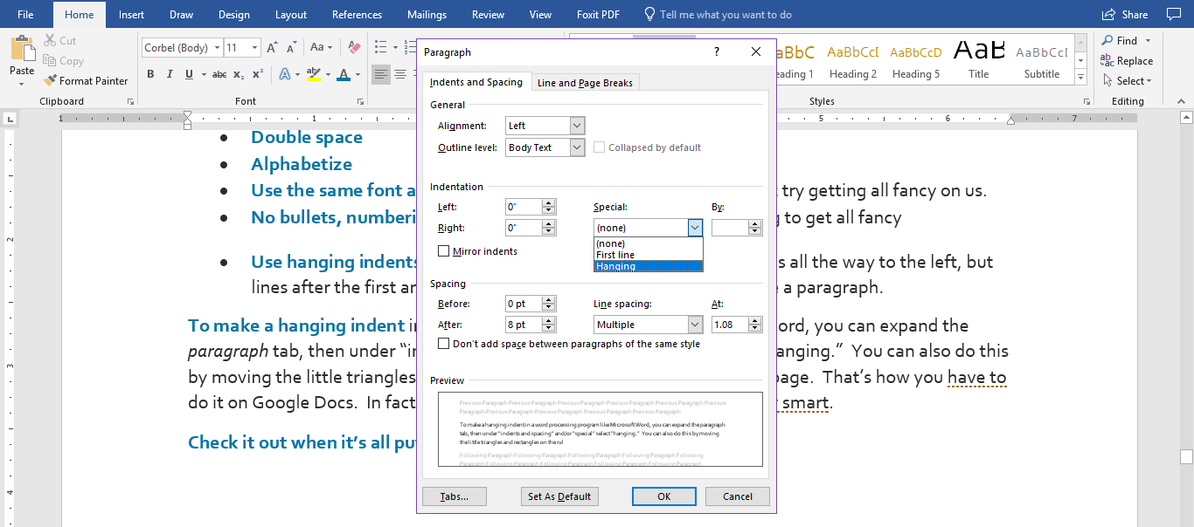
You can also do this by moving the little triangles and rectangles on the ruler at the top of the page. That’s how you have to do it on Google Docs. In fact, when in doubt, just ask Google. She’s pretty smart.

Check it out when it’s all put together:
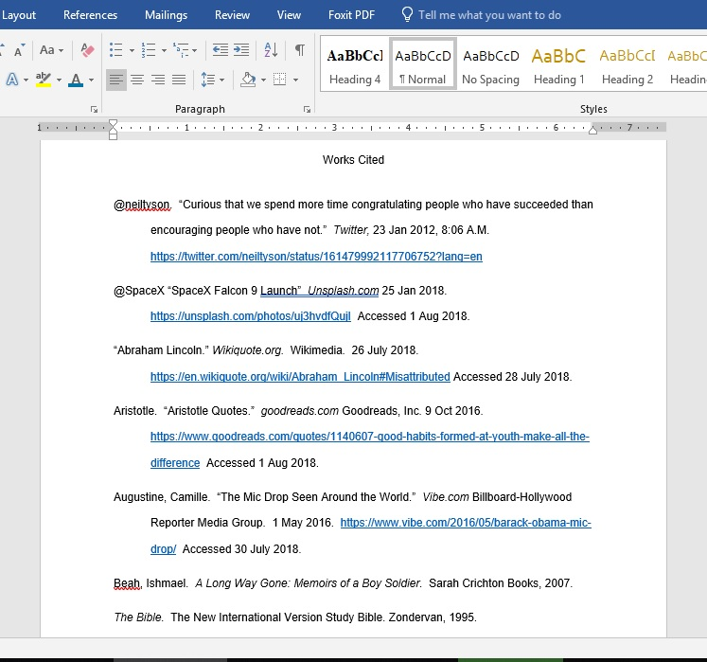
Double spaced
Alphabetized!
Hanging indent
“Works Cited” centered at the top

Basic Format, citations: the Modern Languages Association (MLA) talks about containers and stuff for citations, which can be kind of confusing. Typically, each citation needs:
- Who made it?
- What’s it called?
- Who published it?
- When?
- Where can I find it?
So for books, insert each of the following, including the punctuation:
Author’s last name, first name. Title of book. Publishing company, copyright year.
All of which is easily found on the title page and copyright page:

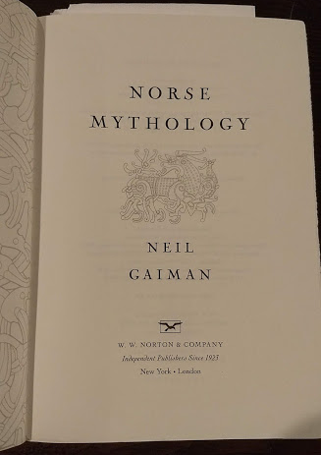
Copyright
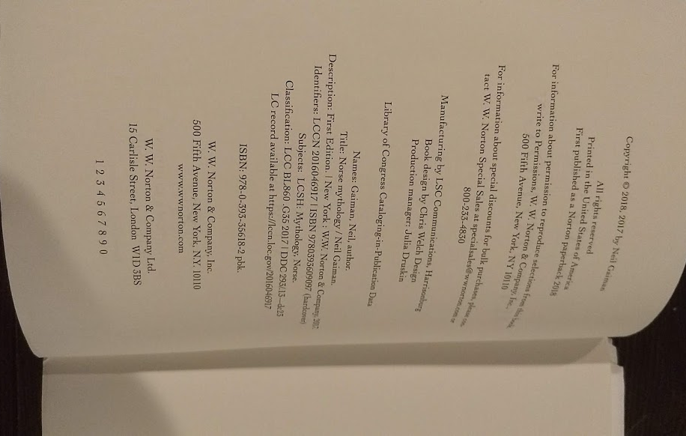
Publisher
Title & Author
Publisher
Author
Title

All together it looks like this:
Gaiman, Neil. Norse Mythology. W. W. Norton & Company. 2018.
Boom! Simple, right? Well, yes, because that was a simple book. OK, then let’s look at a few additions to this basic format.

If you are citing a work that has a translator, editor, and/or multiple editions, you just add that information after the title. For example:
Neruda, Pablo. Selected Poems: A Bilingual Edition. Edited by Nathaniel Tarn. Translated by Anthony Kerrigan, et al. Houghton Mifflin, 1990.
Latin for “and others”
Put a colon between title and subtitle
If you are citing more than one work by the same author, alphabetize by title, then replace the author’s name with three hyphens after the first entry, like this
Rowling, J.K. Harry Potter and the Order of the Phoenix. Bloomsbury, 2004.
--- Harry Potter and the Sorcerer’s Stone. Scholastic, Inc. 1997.

If you are citing a work with more than one author, just add the second author’s name in the format first name last name. If there are more than two authors, put the first author’s name, then the abbreviation et al, (which is Latin for “and others”)
Dai, Danielle and Amanda Fry. “Effect of Video Games on Child Development.” My.vanderbilt.edu Departmental Psychology at Vanderbilt. 24 April 2014 https://my.vanderbilt.edu/developmentalpsychologyblog/2014/04/effect-of-video-games-on-child-development/ Accessed 1 Aug 2018.

If you are citing the scripture such as The Bible, just put the title in italics followed by the version you are using and the publication details, like so:
The Bible. The New International Version Study Bible. Zondervan, 1995.

If you are citing a work from a collection or anthology (like a textbook) do it like so:
Author’s Last name, First name. "Title of work." Title of Collection, edited by Editor's Name(s), Publisher, Year, Page range of entry.
Connell, Richard. “The Most Dangerous Game.” Perrine’s Literature Structure, Sound, and Sense. 9th ed. Edited by Thomas R. Arp and Greg Johnson, Thomson Wadsworth, 2006, 67-85.
That means 9th edition
If you are citing a work from a periodical – like a magazine or newspaper – all the same stuff applies:
Author’s Last Name, First Name "Title of Article." Title of Periodical, Day Month Year, pages.
For example:
Parker, Laura. “Plastic: We Made It. We Depend on It. We’re Drowning in It.” National Geographic, June 2018, 40-69.
Citing an online article that originally appeared in print: If you find an article like the previous one online, cite it the same as you would in print, just add the url and date of access at the end, like so:
Parker, Laura. “Plastic: We Made It. We Depend on It. We’re Drowning in It.” National Geographic, June 2018, 40-69. https://www.nationalgeographic.com/magazine/2018/06/plastic-planet-waste-pollution-trash-crisis/ Accessed 18 Aug 2018.
Again, this doesn’t cover every case you’ll encounter, so if you’re in doubt, go to the latest information online. We highly recommend Perdue OWL.
This same concept goes for any of the previous examples if you read them online (like an ebook, for example): cite them as you would in print, then add sponsoring institution (if you haven’t already – we already had National Geographic in our citation and that’s where we found it online, so we don’t have to list it twice), URL, and date of access.

Citing Electronic Sources
Citing Electronic Sources follows pretty much the same guidelines as books, but it can get pretty hairy out there in the interwebs, so let’s look at some of the more common situations you’ll encounter.
Citing a Website: Not all sites are created equal and you should keep this in mind both when choosing your sources and when citing them. Some websites publish all of the following information clearly whereas others hide it or leave it off. Take a minute to look for as much of the following information as you can. You might have to scroll to the bottom to find a date or click on an info icon . In general, the more reliable your source, the more of this information you will be able to find. If you can’t find most of this information that could indicate your source isn’t very good and you should look somewhere else or verify your information with another source.
Photo by Markus Spiske on Unsplash
Author or Editor’s Last Name, First name (if available). Title of Website. Name of institution, organization, sponsor, or publisher, Date of creation, update or upload, URL or Permalink. Accessed: Date of Access.
For example:
The Purdue OWL Family of Sites. The Writing Lab and OWL at Purdue and Purdue U, 2018, https://owl.english.purdue.edu/owl/. Accessed 29 July 2018.
Citing a Webpage: Most of the time, however, we don’t use an entire website; we only use a page on a website. To cite a webpage, add the author and title of the page to the beginning of your citation:
Sponsor
website
Title of webpage
Author or editor

Bioigraphy.com editors. “Benjamin Franklin Biography.” Biography.com. A&E Television Networks. 1 Aug 2017. https://www.biography.com/people/benjamin-franklin-9301234 Accessed 30 July 2018.
Date of last update or upload

Citing from a Database: If you find an article in an online database like NCWiseowl, add the name of the database after page range. Sometimes academic databases will give you a DOI (Digital Object Identifier), which is preferable to a URL. If so, use that instead of a URL. But the great thing about NCWiseowl is that it will formulate properly formatted citations in any style you choose. Check it out:
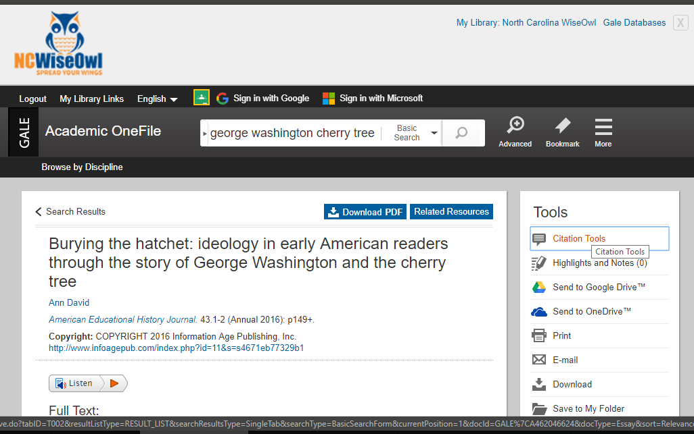
Click here
Which will bring up this box:
Notice you can download it or cut-and-paste
Make sure you choose MLA here
Ta-da!
David, Ann. "Burying the hatchet: ideology in early American readers through the story of George Washington and the cherry tree." American Educational History Journal, vol. 43, no. 1-2, 2016, p. 149+. Academic OneFile, http://link.galegroup.com/apps/doc/A462046624/AONE?u=ncowl&sid=AONE&xid=2be50cb7. Accessed 18 Aug. 2018.
Oh, wait, that’s not right. Did you know that when you paste you have several options on how? To get rid of the source formatting (that icky highlighting and stuff from the webpage) select merge formatting or keep text only and slap a hanging indent on it.
Photo by Aziz Acharki on Unsplash
Excellent!
Not this one
Click that one
So when you’re done, it looks like this:
David, Ann. "Burying the hatchet: ideology in early American readers through the story of George Washington and the cherry tree." American Educational History Journal, vol. 43, no. 1-2, 2016, p. 149+. Academic OneFile, http://link.galegroup.com/apps/doc/A462046624/AONE?u=ncowl&sid=AONE&xid=2be50cb7. Accessed 18 Aug. 2018.
Database name
Citing Images: Let’s start with citing a piece of art:
Artist’s Last name, First name. Title of Work. Date of creation. The museum or institution where the work is housed, City. URL Accessed: Date of Access.
For example:
Picasso, Pablo. Three Musicians. 1921. Metropolitan Museum of Art, New York. https://www.moma.org/collection/works/78630 Accessed 18 Aug 2018.
Citing an Online Image: If the work only appears online, put the artist’s name and the title, then follow the format you would use for a web page:
Barbalis, Chris. Woman’s Torn Face Mural. Unsplash.com 7 Jan 2017. https://unsplash.com/photos/IQIkl2iGnbw/info Accessed 18 Aug 2018.
Citing a Tweet:
Twitter Handle. “The entire tweet in quotation marks.” Twitter, date, time, URL
@neiltyson. “Curious that we spend more time congratulating people who have succeeded than encouraging people who have not.” Twitter, 23 Jan 2012, 8:06 A.M. https://twitter.com/neiltyson/status/161479992117706752?lang=en
Discussion Boards and Blog Postings follow the same basic guidelines:
Author or screen name. “Title of Post.” Name of site, Sponsor or Publisher, URL. Date of Access.
As do YouTube Videos:
Author (if different from uploader). “Title of Video.” YouTube, uploaded by name or screenname of uploader, Date of Upload, URL.
For Example:
“Thor Becomes a Woman – Norse Mythology 6.” YouTube, uploaded by TheSwedishLad, 19 Dec 2013, https://www.youtube.com/watch?v=iAHmVCS-4z8.
Music: Music comes in so many formats these days that citing it can get overwhelming (I know, I know, as if you’re not overwhelmed already), but don’t worry, it’s totally doable.
Start with the artist, song title, album title, recording studio, and release date:
D.J. Jazzy Jeff and the Fresh Prince. “Parents Just Don’t Understand.” He’s the DJ, I’m the Rapper. Zomba Recording, 1988.
That’s how you’d do it if you had the CD or physical album. If you listened to it digitally on Spotify or something, just add that to the end:
D.J. Jazzy Jeff and the Fresh Prince. “Parents Just Don’t Understand.” He’s the DJ, I’m the Rapper. Zomba Recording, 1988. Spotify, https://open.spotify.com/track/4R11j2BjqkwcEmVxEzDQNG
Films: same basic concepts we’ve been doing, but start with the title.
Title. Directed by Director’s name, performance by, list the names of the top 3-5 performers, Studio, Release Date.
For example:
Frozen. Directed by Chris Buck and Jennifer Lee, performances by Kristen Bell, Idina Menzel, Jonathan Groff, and Josh Gad, Walt Disney Animation Studios. 2013.
Again, this doesn’t cover every case you’ll encounter, so if you’re in doubt, go to the latest information online. We highly recommend Perdue OWL.
If you retrieved the film through a streaming service like Netflix or Hulu, just add the name of the service and the URL at the end.
Works Cited

@neiltyson. “Curious that we spend more time congratulating people who have succeeded than encouraging people who have not.” Twitter, 23 Jan 2012, 8:06 A.M. https://twitter.com/neiltyson/status/161479992117706752?lang=en
@SpaceX “SpaceX Falcon 9 Launch” Unsplash.com 25 Jan 2018. https://unsplash.com/photos/uj3hvdfQujI Accessed 1 Aug 2018.
“Abraham Lincoln.” Wikiquote.org. Wikimedia. 26 July 2018. https://en.wikiquote.org/wiki/Abraham_Lincoln#Misattributed Accessed 28 July 2018.
Acharki, Aziz. “Man, Happy, Yes and Agree.” Tangier-Tetouan, Morocco. Unsplash.com 12 Mar 2018. https://unsplash.com/photos/alANOC4E8iM/info Accessed 18 Aug 2018.
Aristotle. “Aristotle Quotes.” goodreads.com Goodreads, Inc. 9 Oct 2016. https://www.goodreads.com/quotes/1140607-good-habits-formed-at-youth-make-all-the-difference Accessed 1 Aug 2018.
Augustine, Camille. “The Mic Drop Seen Around the World.” Vibe.com Billboard-Hollywood Reporter Media Group. 1 May 2016. https://www.vibe.com/2016/05/barack-obama-mic-drop/ Accessed 30 July 2018.
Austen, Jane. Pride and Prejudice. Edited by Carol Howard. Barnes and Noble Classics, 2003.
Barbalis, Chris. Woman’s Torn Face Mural. Unsplash.com 7 Jan 2017. https://unsplash.com/photos/IQIkl2iGnbw/info Accessed 18 Aug 2018.
Beah, Ishmael. A Long Way Gone: Memoirs of a Boy Soldier. Sarah Crichton Books, 2007.
Beller, Michael. “Fantasy Football 2018: Quarterback Tiers.” Sports Illustrated, 17 Aug 2018. https://www.si.com/nfl/2018/08/17/fantasy-football-2018-quarterback-tiers Accessed 19 Aug 2018.
Bender, Howard. “2018 Fantasy Football: Best Ball Draft Strategy Guide, Tips, Targets.” Sporting News. 18 Aug 2018. http://www.sportingnews.com/us/fantasy/sport/news/best-ball-fantasy-football-draft-strategy-tips-targets-cheat-sheet-2018-where-to-play/19th7qhhpuak61w8klrxkjpbms Accessed 19 Aug 2018.
The Bible. The New International Version Study Bible. Zondervan, 1995.
Bioigraphy.com editors. “Benjamin Franklin Biography.” Biography.com. A&E Television Networks. 1 Aug 2017. https://www.biography.com/people/benjamin-franklin-9301234 Accessed 30 July 2018.
Bump, Phillip. “The Answer That Best Exemplifies How Badly Trump Was out of His Depth in the Debate.” Washington Post.com. 27 Sep 2016. https://www.washingtonpost.com/news/the-fix/wp/2016/09/27/the-answer-that-best-exemplifies-how-badly-donald-trump-was-out-of-his-depth-in-the-debate/?utm_term=.7a4aa0885513 Accessed 1 Aug 2018.
Castro, Jessica. Untitled Photograph. Tulsa, OK Unsplash.com 22 Aug 2017. https://unsplash.com/photos/m_fXDnKBEMQ/info Accessed 4 Aug 2018.
Clash, Jim. “Can Elon Musk Really Get us to Mars in 10 Years?” Forbes.com 1 Oct 2016. https://www.forbes.com/sites/jimclash/2016/10/01/can-elon-musk-really-get-us-to-mars-within-10-years/#31df50453884 Accessed 1 Aug 2018.
Connell, Richard. “The Most Dangerous Game.” Perrine’s Literature Structure, Sound, and Sense. 9th ed. Edited by Thomas R. Arp and Greg Johnson, Thomson Wadsworth, 2006, 67-85
Dai, Danielle and Amanda Fry. “Effect of Video Games on Child Development.” My.vanderbilt.edu Departmental Psychology at Vanderbilt. 24 April 2014 https://my.vanderbilt.edu/developmentalpsychologyblog/2014/04/effect-of-video-games-on-child-development/ Accessed 1 Aug 2018.
David, Ann. "Burying the hatchet: ideology in early American readers through the story of George Washington and the cherry tree." American Educational History Journal, vol. 43, no. 1-2, 2016, p. 149+. Academic OneFile, http://link.galegroup.com/apps/doc/A462046624/AONE?u=ncowl&sid=AONE&xid=2be50cb7. Accessed 18 Aug. 2018.
“Edward Nigma (Batman 1966 TV Series).” dc.wikia.com. Fandom. http://dc.wikia.com/wiki/Edward_Nigma_(Batman_1966_TV_Series) Accessed 30 July 2018.
Ellison, Ralph. Invisible Man. Vintage International, 1995.
Frozen. Directed by Chris Buck and Jennifer Lee, performances by Kristen Bell, Idina Menzel, Jonathan Groff, and Josh Gad, Walt Disney Animation Studios. 2013.
Gaiman, Neil. Norse Mythology. W. W. Norton & Company. 2018.
“Great Pacific Garbage Patch.” Wikipedia.org. Wikipedia, the free encyclopedia. 30 July 2018. https://en.wikipedia.org/wiki/Great_Pacific_garbage_patch Accessed 8 Aug 2018.
Heyerlein, H. A face that is covered with glow in the dark paint spots and glitter in Rheinfelden. Rheinfelden, Germany. Unsplash.com https://unsplash.com/photos/ndja2LJ4IcM Accessed 4 Aug 2018.
Johnson, Jens. Headfirst Dive Photo. Gagnef, Sweden. Unsplash.com https://unsplash.com/photos/bGzAOexEZPM Accessed 30 July 2018.
Keilman, John. “Video Games Can Be Good for You, New Research Says.” ChigagoTribune.com 26 Jan 2015. http://www.chicagotribune.com/lifestyles/health/ct-video-games-good-for-you-met-20150126-story.html# Accessed 1 Aug 2018.
Kiser, Taylor. Cake, chocolate, fork and plate. Unsplash.com 12 Sep 2017. https://unsplash.com/photos/tCnOMWITk_4/info Accessed 19 Aug 2018.
Migiro, Geoffrey. “Countries by Percentage of World Population.” Worldatlas.com 18 July 2018. https://www.worldatlas.com/articles/countries-by-percentage-of-world-population.html Accessed 4 Aug 2018.
Parker, Laura. “Plastic: We Made It. We Depend on It. We’re Drowning in It.” National Geographic, June 2018, 40-69.
“Paulo Coehlo Quotes.” Brainy Quote. 2018. https://www.brainyquote.com/quotes/paulo_coelho_406635 Accessed 28 July 2018.
Picasso, Pablo. Three Musicians. 1921. Metropolitan Museum of Art, New York. https://www.moma.org/collection/works/78630 Accessed 18 Aug 2018.
The Purdue OWL Family of Sites. The Writing Lab and OWL at Purdue and Purdue U, 2018, https://owl.english.purdue.edu/owl/. Accessed 29 July 2018.
“Ralph Waldo Emerson Quotes.” Brainy Quote. 2018. https://www.brainyquote.com/quotes/ralph_waldo_emerson_383633 Accessed 28 July 2018.
Rothke, Theodore. “My Papa’s Waltz.” .” Perrine’s Literature Structure, Sound, and Sense. 9th ed. Edited by Thomas R. Arp and Greg Johnson, Thomson Wadsworth, 2006, 997.
Rotker, Alexander. Brooklyn bound. Brooklyn, New York. Unsplash.com. https://unsplash.com/photos/-sQ4FsomXEs/info Accessed 12 Aug 2018.
Rouse, W.H.D. Gods, Heroes, and Men of Ancient Greece: Mythology’s Great Tales of Valor and Romance. Penguin. 1957.
Rowling, J.K. Harry Potter and the Order of the Phoenix. Bloomsbury, 2004.
--- Harry Potter and the Sorcerer’s Stone. Scholastic, Inc. 1997.
Shakespeare, William. Twelfth Night or, What You Will. Mowat and Werstine, eds. Folger Shakespeare Library. https://www.folgerdigitaltexts.org/html/TN.html#line-5.1.0 Accessed 8 Aug 2018.
Spiske, Markus. Untitled. Erlangen, Germany. Unsplash.com 15 May 2018. https://unsplash.com/photos/iar-afB0QQw/info Accessed 18 Aug 2018.
“Syllogism.” K12reader.com. 2018. https://www.k12reader.com/term/syllogism/ Accessed 30 July 2018.
“Thor Becomes a Woman – Norse Mythology 6.” YouTube, uploaded by TheSwedishLad, 19 Dec 2013, https://www.youtube.com/watch?v=iAHmVCS-4z8.
“Thor.” Wikipedia.org. Wikipedia, the free encyclopedia. 23 July 2018. https://en.wikipedia.org/wiki/Thor. Accessed 28 July 2018.
Thoreau, Henry David. Walden, and on the Duty of Civil Disobedience. Project Gutenburg ebook. 2013. https://www.gutenberg.org/files/205/205-h/205-h.htm#linkW2. Accessed 28 July 2018.
Tumbokon, Ronaldo. “25+ Positive and Negative Effects of Video Games.” Raisesmartkid.com 18 June 2018. https://www.raisesmartkid.com/3-to-6-years-old/4-articles/34-the-good-and-bad-effects-of-video-games Accessed 1 Aug 2018.
“Troll Quotes – Don’t believe everything you read on the internet.” Know Your Meme. Literally Media, LTD. 2018. https://knowyourmeme.com/photos/1201185-troll-quotes Accessed 28 July 2018

