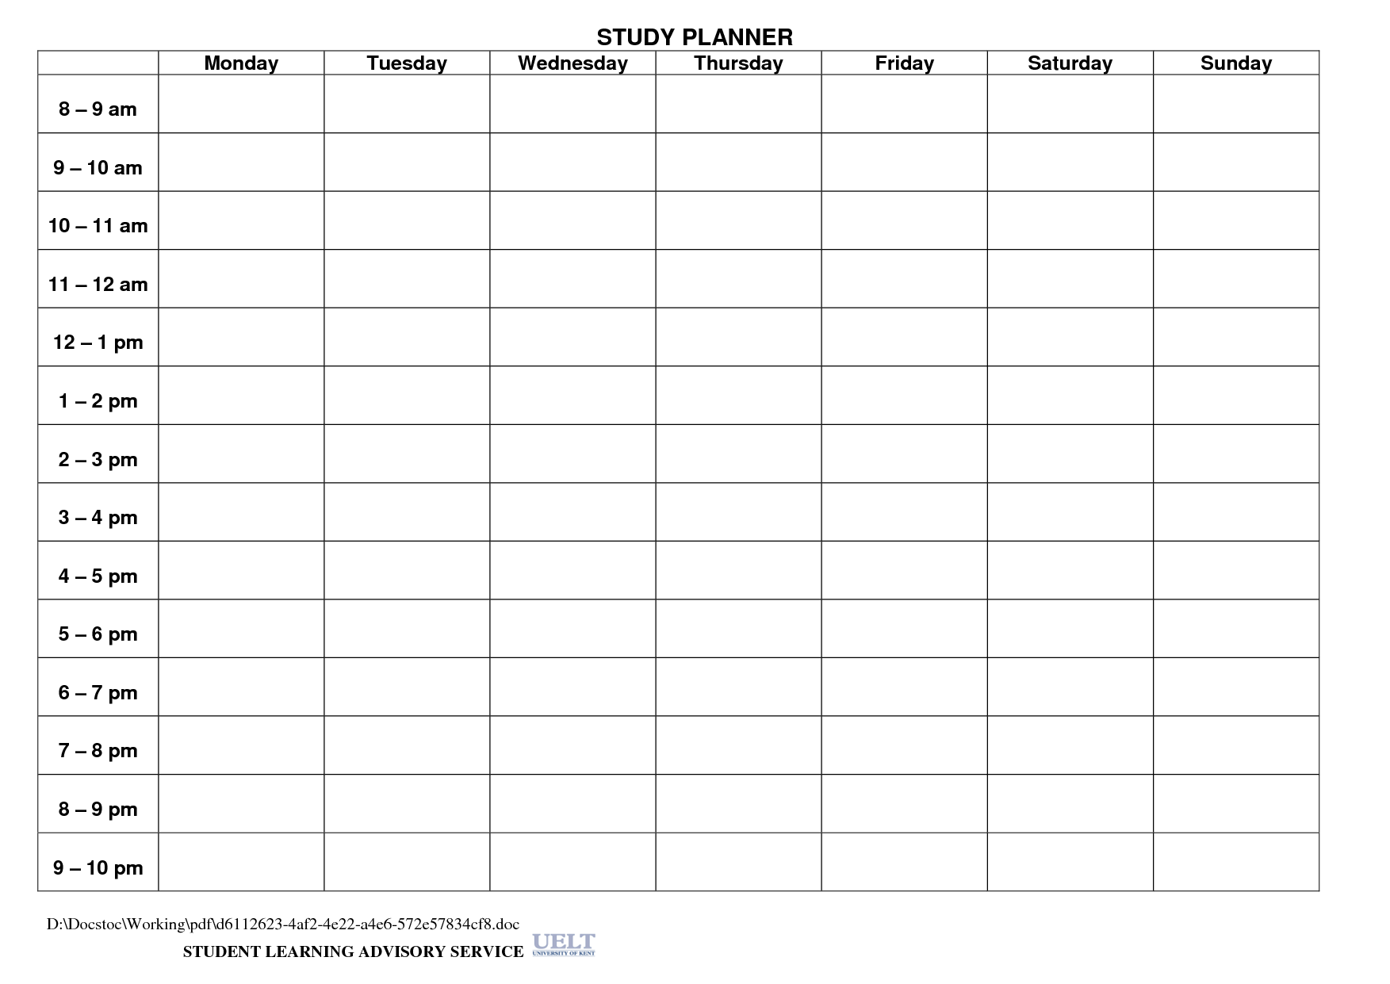

Get ready for school

Example:

My school day

Tutoring- English

HW, friends

Dinner/Chores

Math- ch 1

English Unit 1

Watch TV .5hr

Get ready for bed

